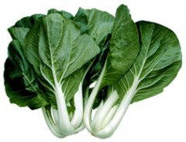
Chinese Pak Choi
This widely grown Asian green, also called bok choy, has smooth green leaves and thick white leaf stalks. It is one of the most popular Asian vegetables and a main ingredient in chow mein and stir-fries. Can be steamed, stir-fried, and braised. Used in soups, for ohitashi, and pickles.

Germination Temperature: 50-80°F

Planting Depth: 1/4"-1/2" (If planting a “field” of pak choi, space rows 18-24" apart.)
Seed Spacing: 6-8” (Can be seeded 1-2” apart and the weaker sprouts thinned.)

Maturity: 40-50 days.

Very low in saturated fat and cholesterol, and a good source of dietary fiber, protein, thiamin, niacin and phosphorus. A very good source of Vitamins A, B6, C, and K, riboflavin, folate, calcium, iron, magnesium, potassium and manganese. Note: High sodium content, and large portion of calories come from sugars.
https://nutritiondata.self.com/facts/vegetables-and-vegetable-products/2377/2#ixzz5OwmssIQz

