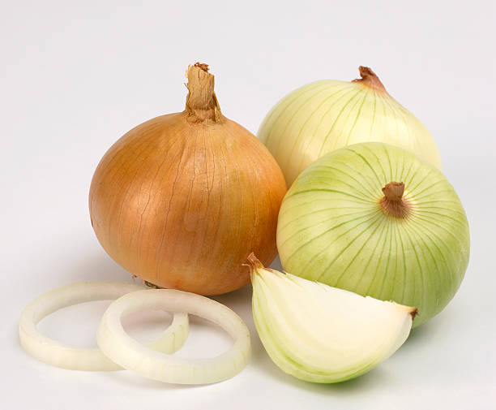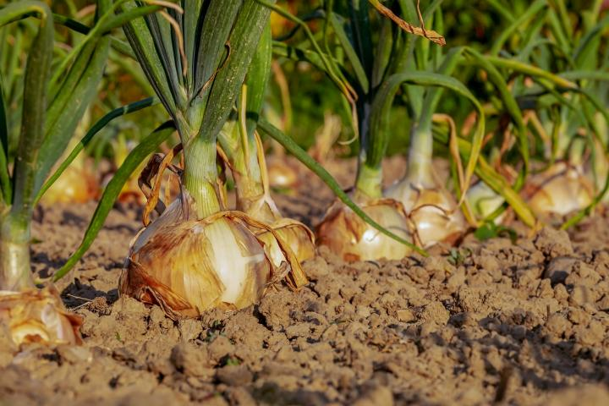
Sweet Onions
Culture: Sweet onions grow best in rich soft soil or loam, although they tolerate most soils if you add sufficient and balanced fertilizer.
Spacing: Build slightly raised rows 18 inches wide. Make very small holes 1-inch deep, spacing them 6-inches apart. Plant an onion in each hole barely covering the root end (approximately ½-inch deep). Water enough so that soil is washed around root. Consider succession planting – transplant six now, six in 2 weeks, six more in 4 weeks for a continual harvest.
Irrigation: Onions need soil that is moist but not wet. (Do not saturate the soil.) On windy or sunny days, onions will require watering to keep the soil moist. Otherwise, watering 2-3 times a week with approximately ½-inch – 1 inch of rain equivalent will keep the soil moist.
Fertilization: Apply a complete balanced fertilizer when you plant. After that, apply a nitrogen fertilizer monthly and irrigate frequently to promote steady growth. https://gardeningsolutions.ifas.ufl.edu/plants/edibles/vegetables/onions-and-shallots.html#:~:text=Apply%20a%20complete%20balanced%20fertilizer,the%20tops%20have%20fallen%20over.
Harvest: Young onions can be harvested and eaten at any stage of growth. As the bulb grows, you can continually cut the green section and leave the bulb to mature. From planting to harvest, these onion sets will mature in 50-60 days. When most of the onion tops have fallen over and start turning brownish, and the bulbs start to show skins, they are mature. They can remain in the soil 7-10 days, which allows them to begin drying. (Tipping the onion bulbs over to break the roots will speed up drying.) Discontinue watering for a couple days and harvest on a dry day.
Compatible with carrots, beets, cabbage, carrots (repel the carrot fly), lettuce, parsnips, and tomatoes. Trouble with aphids; onions will chase them away! Incompatible with asparagus, beans, and peas.

