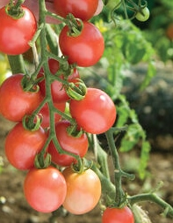
Sunpeach, Hybrid
Sunpeach, a sister variety to Sungold, is less tangy & acidic as its famous orange relative but is very sweet with excellent flavor. Deep pink, shiny, 15-20 gm., fruit are borne on long trusses. Vigorous, healthy, high-yielding plants. High resistance to leaf mold helps it stay healthy in high tunnels; also has high resistance to tomato mosaic virus. Resistant to cracking.

Climate: Transplant when soil temperature is at least 55-60°F. Vigorous plants start yielding early and bear right through the season.

Spacing: Space seedlings 24 inches apart. Transplant so that soil level is just below the lowest leaves. Train to vertical support or set cage into ground immediately after transplanting.

Irrigation: Require 1-2 inches of water each week, depending on weather conditions. Water early in the day and avoid getting water on stem and foliage to prevent disease. Keep soil evenly moist.
Fertilizer: Granular Nature Safe 5-6-6 and Blood Meal, along with Compost Plus, Micros Plus, and Capacity Plus, used at VISTA at the beginning of the Fall season are good starter fertilizers. Sunpeach tomatoes are heavy feeders. Apply tomato and vegetable fertilizer every 3-4 weeks once fruit forms. Caution: Too much nitrogen causes rampant growth and softer fruits.

Matures 60 days after transplant.

https://www.totallytomato.com/category/s?keyword=Sungold

https://gardeningsolutions.ifas.ufl.edu/plants/edibles/vegetables/cherry-tomatoes.html

Tomatoes are incompatible with broccoli, cauliflower, corn, and dill. Carrots grown with tomatoes will have good flavor but stunted roots. Compatible with basil, beans, chives, cucumbers, garlic, lettuce, marigolds, nasturtium, onion, parsley, and rosemary; all of which help control pests.

