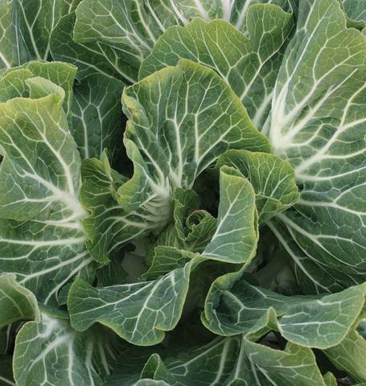
Portuguese Collards/Kale
This hybrid variety originating in Portugal produces wide, blue-green leaves with a prominent white midrib. It is heat resistant and it welcomes the colder months with a sweeter and more nutritious harvest of greens. The leaves are traditionally used in soups and stews such as Caldo Verde, the national soup of Portugal.
Culture: Prepare fertile, well-drained soil with 6.5 pH. Prefers full sun, but can benefit from light shade during hot weather.
Spacing: Sow seeds ¼ - ½" deep, 1" apart. Thin to 12 – 18", depending on whether you plan to harvest outer leaves continually or the entire, mature plant in 75 days. Plant will grow 24" high.
Irrigation: Water the seeds, and keep the soil evenly moist. With adequate moisture, the seeds should germinate within seven to 10 days. Water the seedlings regularly so that they receive about 1½ inches of water each week.
Fertilization: Work 1/2 cup of balanced fertilizer into the soil around each seedling. Portuguese kale plants are heavy feeders and need added soil nutrients for vigorous growth.
Maturity: When plants reach 12" tall, cut individual leaves from the outside, leaving 3 inner layers to support further growth. Use leaves as you would collards and mustards. Excellent juiced. Alternatively, harvest entire mature plant in 75-85 days.
https://www.kitazawaseed.com/seed_586-204.html
…Noteworthy are its prominent white stems and ribs, which are a bit like those of the totally unrelated Swiss chard, but not as wide. These are more tender than kale ribs and can be used as a vegetable in their own right or chopped up and simmered in the soup. https://www.washingtonpost.com/lifestyle/home/a-collard-relative-from-portugal-goes-mainstream/2016/02/22/9cdcd69c-d4ca-11e5-9823-02b905009f99_story.html

Kale is compatible with beets, celery, cucumbers, dill, lettuce, nasturtium, onions, spinach, Swiss chard, and many herbs (especially in the mint family). It is incompatible with tomatoes and strawberries.

