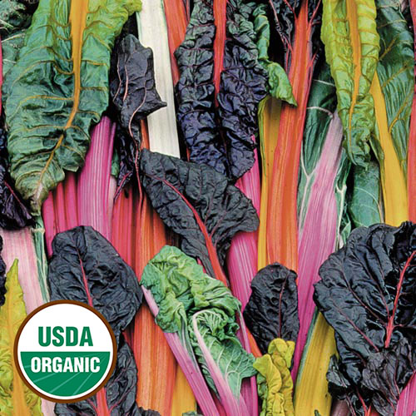
Swiss chard, Five Color Silverbeet
(aka Rainbow Chard) Australian heirloom from Digger’s Garden Club. Technicolor mixture of Swiss chards with shades of red, orange, purple, yellow, and white (on the ribs) tastes as good as it looks. Tender and delicious.

Culture: Prepare fertile, well-drained soil. Grows best in full sun but tolerates partial shade. Swiss chard withstands light frost.

Spacing: Direct sow 1/2" deep, 4" apart. Thin to 12" apart.

Irrigation: Water Swiss chard evenly and consistently to help it grow better.

Fertilizer: Plant with organic compost and granular Nature Safe 5-6-6 and Blood Meal, as well as the Compost Plus, Micros Plus, and Capacity Plus used at VISTA at the beginning of the Fall season. Foliar applications of an all-purpose organic fertilizer and liquid kelp 2-3 times during the gardening season will boost production.

Matures in 50-60 days, although you may harvest sooner.

When the plant has a strong root structure, harvest a couple of leaves from each plant. Always pluck or cut leaves when young and tender. Take a few from each plant, leaving 2/3 of the plant intact unless there is crowding or signs of bolting. In this case, harvest an entire plant immediately.

Plant will grow to 22-24" high. Mature plants can be cut back to 1-2" above soil for re-growth for a cut-and-come again harvest.

https://www.seedsavers.org/five-color-silverbeet-organic-swiss-chard

Loaded with health benefits, this amazing superfood is an excellent source of vitamins A, C and K, as well as minerals like iron, magnesium, copper and potassium. Swiss chard is virtually fat-free, making it a heart-healthy choice, and contains significant amounts of dietary fiber. Plus, like other leafy greens, it is chock-full of antioxidants and many other disease-fighting properties. Chard is​ ​one of​ ​the​ ​food crops being grown​ ​by​ ​astronauts aboard the International Space Station. It was ​selected​ ​for its​ ​high nutrient ​profile, compact habit and ease of growth.
https://www.planetnatural.com/growing-chard/

Beans, brassicas, and onions make the best companions for Swiss chard. It is also compatible with tomatoes and can benefit from the shade provided by tomato foliage.

Swiss chard should not be planted near potatoes, corn, cucumbers, or melons. All of these will either compete for soil nutrients or foster harmful pests.

