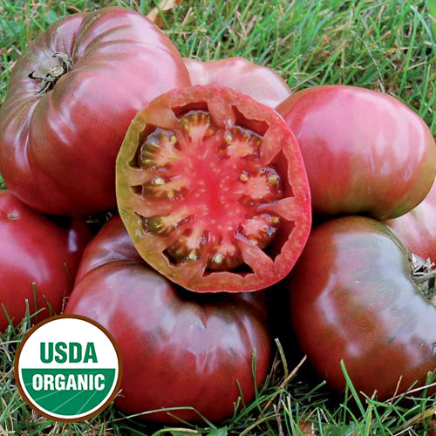
Cherokee Purple, Heirloom
Introduced by Craig LeHoullier of Raleigh, NC, in 1991 from seed obtained from J. D. Green of Tennessee. Uniquely colored dusty rose-brown fruits weigh up to 12 ounces. Delicious sweet flesh. Cherokee Purples are some of the most eye-pleasing and distinctive of tomatoes in both appearance and taste.

Climate: Transplant when soil temperature is at least 60°F. This tomato thrives in 6-6.5 soil pH.

Spacing: Space seedlings 24 inches apart. This plant grows large! Transplant so that soil level is just below the lowest leaves. Train to vertical support or set cage into ground immediately after transplanting.

Irrigation: Keep soil evenly moist. Water early in the day if the top 1 to 2 inches of soil feels dry to the touch. Never allow the soil to become either too soggy or too dry. Uneven moisture levels can cause cracked fruit or blossom end rot.
Fertilizer: Granular Nature Safe 5-6-6 and Blood Meal, along with Compost Plus, Micros Plus, and Capacity Plus, used at VISTA at the beginning of the Fall season are good starter fertilizers. Continue regular feeding with reduction in nitrogen, using a fertilizer with more phosphorus and potassium that also contains calcium.
Matures 75-90 days after transplant.

Grown from seeds saved by Karen Rose, Chair, House of the Rising Seeds, VISTA Gardens

Seeds available from:
https://www.southernexposure.com/products/cherokee-purple-tomato/

https://gardeningsolutions.ifas.ufl.edu/plants/edibles/vegetables/cherry-tomatoes.html

Tomatoes are incompatible with broccoli, cauliflower, corn, and dill. Carrots grown with tomatoes will have good flavor but stunted roots. Compatible with basil, beans, chives, cucumbers, garlic, lettuce, marigolds, nasturtium, onion, parsley, and rosemary; all of which help control pests.

