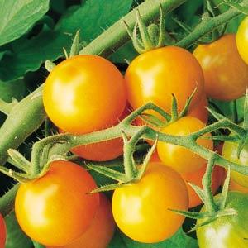
Sun Gold, Hybrid
Bright tangerine-orange cherry tomatoes from Japanese origin, this orange cherry variety has an incredibly sweet, almost fruit-like flavor and is rapidly becoming the most popular cherry tomato of all time. Fruits are borne in large clusters and the flavor develops early, so this little tomato is great for snacking a week before full maturity, when it becomes very sweet and delicious.

Climate: Transplant when soil temperature is at least 55-60°F. Vigorous plants start yielding early and bear right through the season. High resistance to fusarium wilt and tobacco mosaic virus.

Spacing: Space seedlings 18-20 inches apart. Transplant so that soil level is just below the lowest leaves. Train to vertical support or set cage into ground immediately after transplanting.

Irrigation: Require 1-2 inches of water each week, depending on weather conditions. Water early in the day and avoid getting water on stem and foliage to prevent disease. Keep soil evenly moist.

Fertilizer: Granular Nature Safe 5-6-6 and Blood Meal, along with Compost Plus, Micros Plus, and Capacity Plus, used at VISTA at the beginning of the Fall season are good starter fertilizers. Sungold tomatoes are heavy feeders. Apply tomato and vegetable fertilizer every 3-4 weeks once fruit forms. 4-6-8 NPK ratio recommended by Totally Tomatoes.

Matures 57 days after transplant.

https://www.totallytomato.com/category/s?keyword=Sungold

https://gardeningsolutions.ifas.ufl.edu/plants/edibles/vegetables/cherry-tomatoes.html

Tomatoes are incompatible with broccoli, cauliflower, corn, and dill. Carrots grown with tomatoes will have good flavor but stunted roots. Compatible with basil, beans, chives, cucumbers, garlic, lettuce, marigolds, nasturtium, onion, parsley, and rosemary; all of which help control pests.

