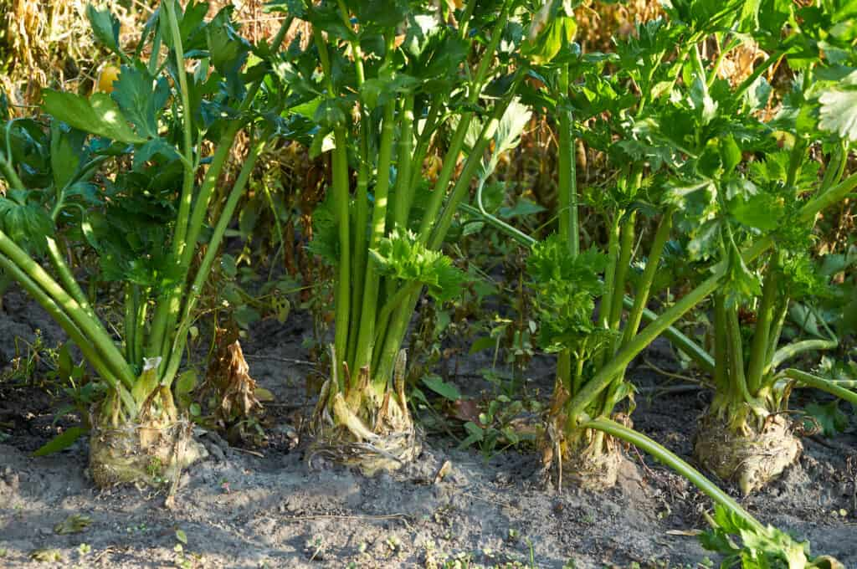
Celeriac, Mars
Large, uniform roots with big, healthy plants. Interiors stay firm, even when roots are large. Holds well in the ground. Upright plant results in less splash from rain and, hence, less soilborne Septoria blight as well as easier cultivation. USDA Certified Organic.
Note: In rare instances, contact with the foliage can result in a severe rash. When working with this crop on hot, sunny days, Johnny’s seed company recommends wearing long sleeves and long pants and washing any exposed skin surfaces as soon as possible after contact.
Culture: Fertile soil with a pH range of 6.0–7.0. A generous amount of compost worked deeply into the soil before planting helps retain moisture and add nutrients. Grows best in cool weather, especially when nights are cool.
Spacing: Sow 6 seeds per inch, 1/8" deep. Seedlings typically emerge in 2–3 weeks. When they are 3-4 inches tall, thin to 6–8" apart.
As the plants grow, soil can be mounded around the exposed root to keep it moist and cool.
Irrigation: Requires consistent supply of moisture throughout the season for optimum flavor and yield. Consider mulching with food-grade straw to conserve soil moisture. Do not let the soil dry out!
Fertilization: Apply every 3-4 weeks with a high potassium fertilizer (4-4-8, for example).
Remove lower and lateral leaf shoots while celeriac is growing to produce a nice crown. Leaves can be used to flavor soups and stews.
Maturity: 95 days. Harvest when 3–5" diameter. After harvest remove field heat by dunking plants in cold water.
VISTA purchased pelleted seeds for easier planting. Consistent soil moisture is important during the germination period. Pellets are made of inert NOP-compliant materials, having met the standards established by the USDA’s National Organic Program. Pelleted seed must be kept cool and dry prior to planting and should be used within one year of purchase.
https://www.johnnyseeds.com/vegetables/celery-and-celeriac/celeriac-celery-root/mars-organic-pelleted-celeriac-seed-660GP.html

Compatible with lettuce, spinach, English peas. Do not plant celeriac with pumpkins, cucumbers, or squash.

