Alaska Dwarf Nasturtium
(Tropaeolum majus)
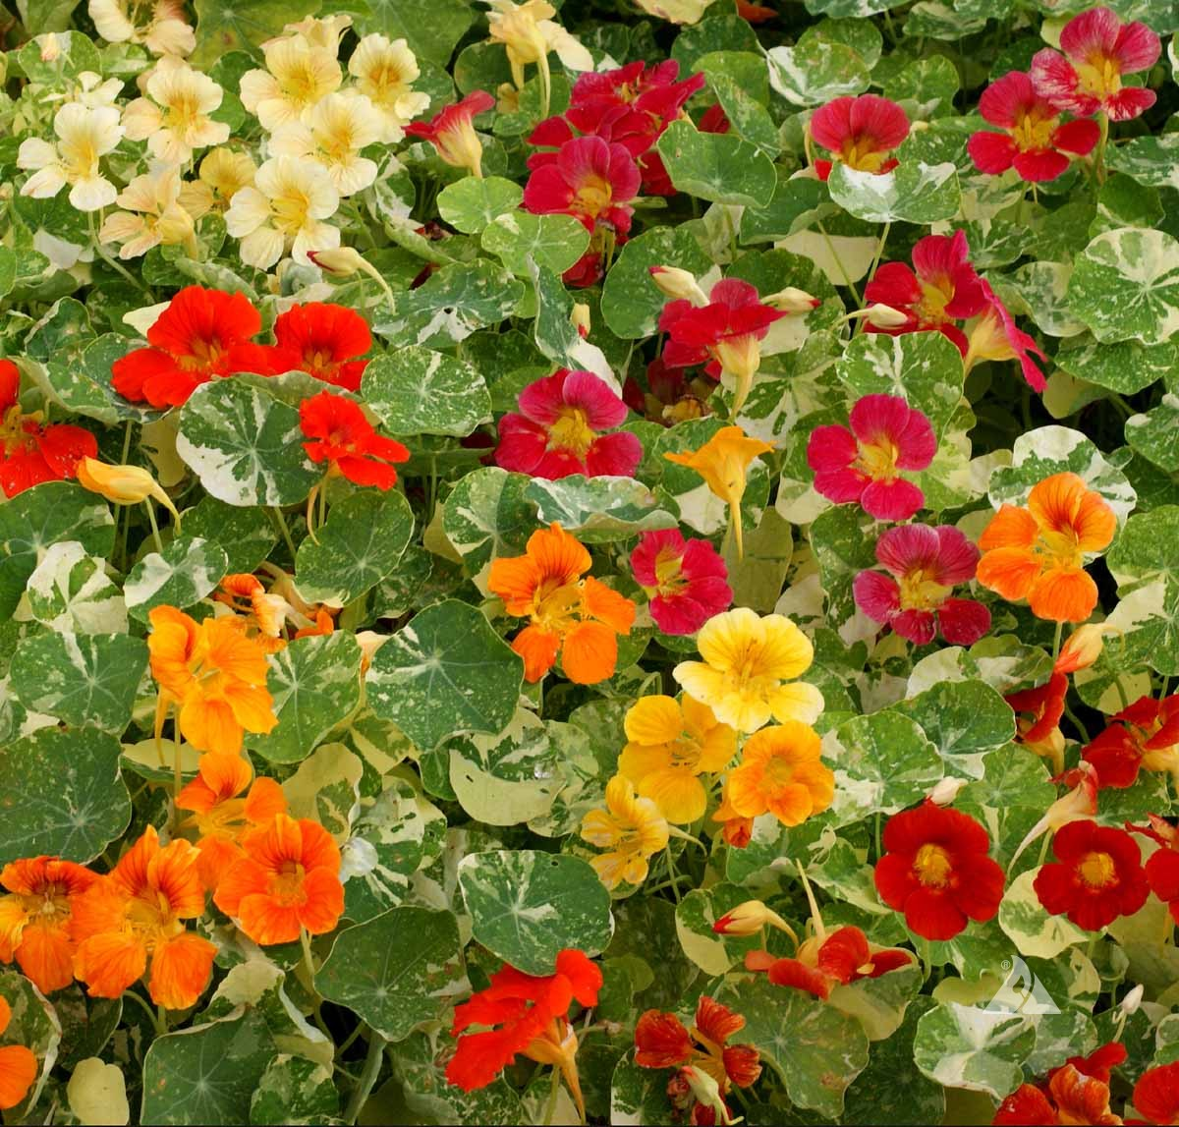
Nasturtiums are an easy to grow flowering annual with edible leaves, pods, and blooms. The flavor is described as similar to that of watercress. A compact mound-shaped growth habit achieving 12” tall is perfect in small gardens. The plant has round and smooth leaves that are marbled green and white and produces brightly colored flowers in yellow, crimson, orange, salmon and cherry. Maturity is 32-40 days. Fertilization promotes vigorous leaf growth and fewer flowers. This variety is known to deter rabbits from your garden.

https://www.johnnyseeds.com/flowers/nasturtium/alaska-mix-nasturtium-seed-1202.html

