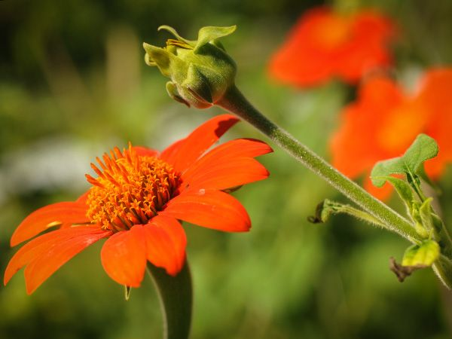
Red Torch Mexican Sunflower
Tithonia rotundifolia

Brilliant, red-orange, 2-3 inch flowers; an excellent butterfly plant. These bloom over a very long season, and the plants produce masses of blooms. The large 5-foot plants are very beautiful. I enjoyed these as I traveled along the roadsides in the high mountains in central Mexico.
We grew this sunflower for the first time this year and I was blown away by it's size and beauty. The flower itself does not look like a sunflower in the typical sense. The bloom is on the smaller side. The height of the plant itself is reminiscent of a sunflower though. Each plant is covered in many, many blooms. We planted these along the back side of our barn and they were just gorgeous. I would visit this plot frequently to take cuttings and they were beautiful in a vase. The deep reddish orange color is unreal. Very highly recommend! Review, January 2020
https://www.rareseeds.com/store/flowers/sunflower/mexican-sunflower-red-torch
Lifecycle: Annual Season: Summer to fall
Seed to Bloom: 12-14 weeks Sun: Full sun Soil: Regular to rich, well-drained

Mexican sunflowers grow just fine without any supplemental fertilizer. In areas with especially depleted soils, you can add an all-purpose flower fertilizer at the beginning of the season to get plants off to a quick start.
If growing in container, plant the Mexican sunflower in the center of the pot, and add trailing plants like million bells or portulaca that also appreciate full sun and drier conditions. Use a soilless potting mix with good drainage.
According to the California Poison Control System, Mexican sunflowers are non-toxic to cats and dogs.
Pruning Mexican sunflowers isn’t necessary but can help to get lanky plants under control or to keep overgrown plants in bounds. Keep in mind that you may sacrifice some blooms when pruning. Cut off the top one-third of the plant when it’s experiencing a lull in blooming to both deadhead and tidy the plant.
Snails and slugs sometimes bother Mexican sunflowers, especially in rainy weather. Place a piece of damp cardboard beside plants and collect the pests when they hide during daylight hours [or lightly sprinkle “Sluggo Plus” as a deterrent.]
Information adapted from:
https://www.thespruce.com/mexican-sunflower-plant-profile-4687502
Some Mexican sunflowers are invasive and not recommended by the University of Florida Institute of Food and Agricultural Sciences (IFAS), but Tithonia rotundifolia is an acceptable sunflower to plant.
https://www.jacksonville.com/lifestyle/20191213/garden-qa-mexican-sunflower-is-lovely---but-dont-plant-wrong-one

