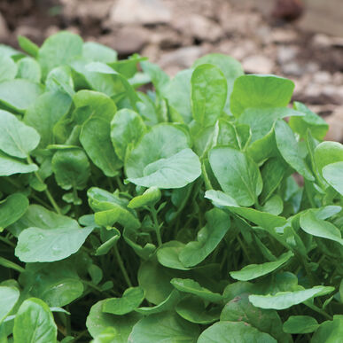
Upland Cress Salad Greens
Upland Cress is also called Winter Cress, or Creasy Greens in the South. Although sometimes slow to start, this is generally easier to grow than watercress and a good cut-and-come again crop that is 4-6" tall with mildly peppery leaves. Leaves, shoots, and flower buds are all delicious. Adds zesty flavor to salads, soups, eggs, and sandwiches. Use as a fresh garnish to complement grilled vegetables or fish. Rich in iron, calcium and vitamins A and C.

Culture: Prepare fertile, well-drained soil. Germination temperature 55-75˚F. Prefers cool temperatures and will bolt when heat sets in.

Spacing: Sow seeds ¼" deep by broadcasting or seeding 1" apart. Thin sprouts, leaving 4 inches between each. For a continuous supply, plant seeds every 2-3 weeks over the growing season.

Irrigation: Keep soil consistently moist, as the seeds germinate slowly over two-week period. Continue to water regularly to maintain even soil moisture, but do not soak.

Fertilization: Requires moderate levels of nutrients. Amend soil with compost before planting.

Maturity: 45-60 days. Harvest at any stage from microgreens to full maturity.

https://www.kitazawaseed.com/seed_182-157.html

Grows well with beets, carrots, sunchoke, corn, sunflowers, pole beans, dill, lettuce, onion, spinach, tomato, nasturtium, and cilantro.

