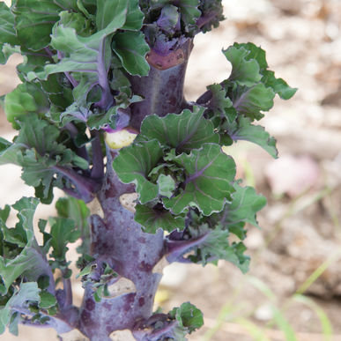
Snow Drop F1 Kalette®
Kalettes resulted from breeding crosses between Brussels sprouts and kale, resulting in small open, flower-like florets.

Time transplant so that plants are 2-3 feet tall prior to onset of cold weather and lower light levels of winter months. September is recommended in the deep South.
Space - 18 inches apart

Growing Conditions: Plant in fertile soils with a pH above 6.5-7.5. To maintain steady growth, irrigate in dry weather and fertilize at 75% the amount of nitrogen as you would Brussels sprouts. Excessive nitrogen will cause overly leafy and unattractive florets.

Care and harvest tips: For earlier, more concentrated production, top the plants by pinching out the growing point at the top of the plants. This should be done when the florets lower on the stem are ½-¾" in
diameter. When plants are topped, the top florets will mature first. The tops of the plants may be bunched for cooking greens, much like kale.

Days to Maturity – 138 - Harvest florets when they are approximately 1½-2 inches in diameter. A light frost will improve flavor.

https://www.johnnyseeds.com/vegetables/kalettes/autumn-star-f1-kalettes-seed-3139.html

