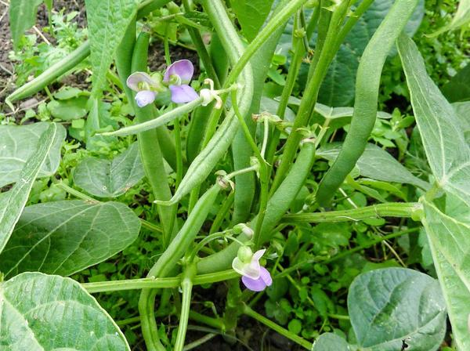
Bush Bean - Tendergreen Improved

A great garden-bean variety for canning and freezing, as well as fresh eating. They are not only heat tolerant, but disease resistant as well. Productive bush-type plant that bears tender stringless pods 6" long. Enjoy raw or lightly cooked.

Culture: Light, well-drained soil with pH of 6.0-6.2. Adding inoculant at planting time aids in a larger harvest and more robust plants.

Spacing: Direct sow seeds 1" deep, 3" apart in rows 2' apart. Press down the earth above them for good soil contact. Sow a few times a season, 2-4 weeks apart for a continuous harvest.

Irrigation: These seeds rot easily in wet soil, so do not overwater them. After germination (7-12 days) maintain soil moisture. Beans have shallow roots and need regular watering if the weather is dry. Provide adequate, even moisture, especially at flowering time. Dry soil can result in low yields and fibrous pods. Mulching with oak leaves around bean plants maintains moisture and inhibits weeds.

Fertilizer: Adding inoculant at planting time aids in a larger harvest and more robust plants. Do not over fertilize with nitrogen which results in a surplus of foliage and low, delayed pod growth. A side-dressing of compost may be sufficient, although some gardeners add a low nitrogen fertilizer at the time of flowering.

Matures in 52 days Note: Harvest the pods before the seeds inside bulge, and harvest often to encourage more production.

Expect first harvest about ten weeks after germination. Daily harvest improves production. For best flavor and tenderness, pick the beans when they are no larger than the thickness of a pencil or 4-8" long. For the freshest taste, cook or preserve them the day of harvest.

https://www.everwilde.com/store/Tendergreen-Improved- Green-Bean-Seeds.html

For companion planting benefits, grow beans near carrots, cucumbers, or corn; avoid planting them near onions.

