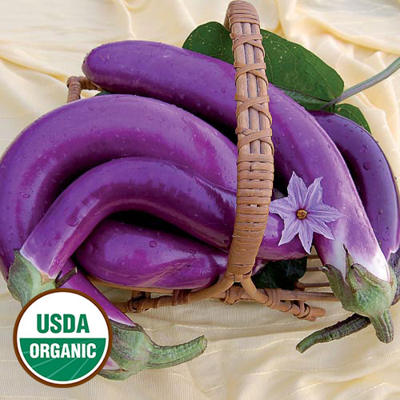
Pingtung Long Eggplant

This versatile variety matures earlier than most and is a perfect choice to use in an appetizer or side dish. A beautiful eggplant from Pingtung, Taiwan, with slender fruits that grow up to 12" long with shiny, dark-lavender skin. Produces very well, even in very hot weather.

Hardy, vigorous, and disease-resistant plants. Tip: Prevent verticillium wilt by planting eggplants away from areas that held tomatoes, peppers, or potatoes in the previous three years.

Each plant requires 18-24 inches of space in your garden bed.

Eggplants are heavy feeders. Sensitive to nitrogen; if over fertilized, they will grow excessive foliage and produce less fruit. Use a high phosphorous starter.

Mature 65-75 days after transplant. Regular harvest increases production of fruit.

