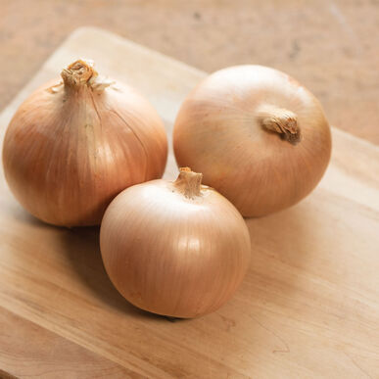
Calibra, Yellow Onions, Organic

New! Hard, intermediate-day storage onion for more Southern latitudes. This "long-intermediate" onion forms large bulbs farther south than our other hard storage onions. Robust, upright green tops for improved thrips resistance. Strong bronze skins. Excellent storage potential (6+ months).

Culture: Full sun and fertile, well-drained soil with a pH of 6.0–7.0. Keep well weeded with shallow cultivation.

Space: Sow 2 seeds per inch, 1/4– 1/2" deep, in rows 12–18" apart. Thin to 2" apart for highest yields or to 3-4" apart for larger onions.

Irrigation: Onions are shallow-rooted and grow best with at least 1" per week of rain or irrigation, especially during the bulbing phase.

Fertilize: Apply first application (high nitrogen, such as blood meal) three weeks after planting and every 2 to 3 weeks thereafter.

Mature: 110 days. When necks become soft and tops are falling over, pull and sun-cure at least 2–7 days, depending on weather. Move to a protected location to finish drying.

When dry, clip off tops and roots and store in onion bags or shallow boxes at near freezing and 65–70% humidity.

https://www.johnnyseeds.com/vegetables/onions/full-size-onions/calibra-organic-f1-onion-seed-4578G.html

Onions are compatible with tomatoes, sweet peppers, spinach, lettuce beets, parsnips. Onions also repel insect pests of strawberries.

Incompatible with peas and beans.

