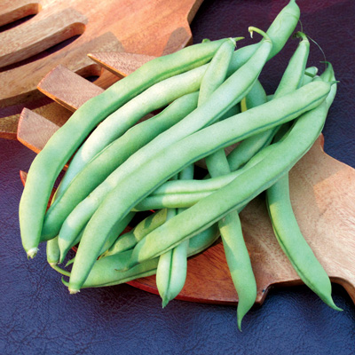
Blue Lake Pole Beans
This vigorous, 7' tall variety made Oregon's Willamette Valley famous in the 60s and 70s for canning beans. The smooth, 6-7"green pods have a straight, yet plump shape. Harvested at their peak, you'll find them tender, meaty, and full of hearty, fresh bean flavor. White seeds.

Rich and flavorful beans are fiber-packed veggies that promote digestive health and are excellent sources of antioxidants that scavenge free radicals in the body. They are also nitrogen-fixing legumes; beans gather nitrogen from the air and load it into the soil to feed future crops.

Culture: Ideal soil pH is 6.5. Ideal soil is temperature is 60-85°F. Enrich soil prior to planting. Germination requires temperatures of 70 degrees to 80 degrees. Seedlings emerge in eight to 10 days. Set support structure into place before planting to avoid damaging the bean plants’ roots.

Spacing: Direct sow 1-2” into ground 4-8” apart. Avoid overcrowding plants to allow for adequate air circulation. Succession plant seeds every 2 to 4 weeks for continuous harvest.

Irrigation: Soil must be moist to ensure healthy plants and productive crop. Water early in the day and avoid getting the foliage wet. Beans are shallow rooted and can require up to 1/4 inch of water a day during hot weather. (More watering is necessary during extremely hot and dry weather.) During flowering and pod development, maintain consistent moisture of about one inch per week.

Fertilization: Require minimal fertilization, providing they are planted in enriched soil. Some gardeners add 1 cup of compost tea to the surrounding soil every 10 days with good results.

Maturity: Germinates in 8-16 days. Harvest in 75 days. (Expect your first beans 10 weeks after they germinate.)

https://www.everwilde.com/store/Organic-Blue-Lake-Bush-Green-Bean-Seeds.html

VISTA Gardens is also trying Blue Lake S-7 Stringless Pole Bean from Vermont Bean Company during Fall 2021 growing season, described as:
“All-America 2003 winner. It is an early maturing variety that has sparse foliage for easy picking. The 6 to 6-1/2 inch pods are borne on spurs extending out from the vine. Plants are very productive on vigorous vines that can extend to 7 feet. You will need a trellis, tee-pee or fence to make them easier to pick. A real winner!!” 60-day maturity
https://www.vermontbean.com/product/V01156/208

For companion planting benefits, grow with carrots, celery, chard, corn, cucumber, eggplant, peas, potatoes, radish and strawberries. Avoid planting near chives, garlic, leek, and onions. Pole beans and beets may stunt each other’s growth.

