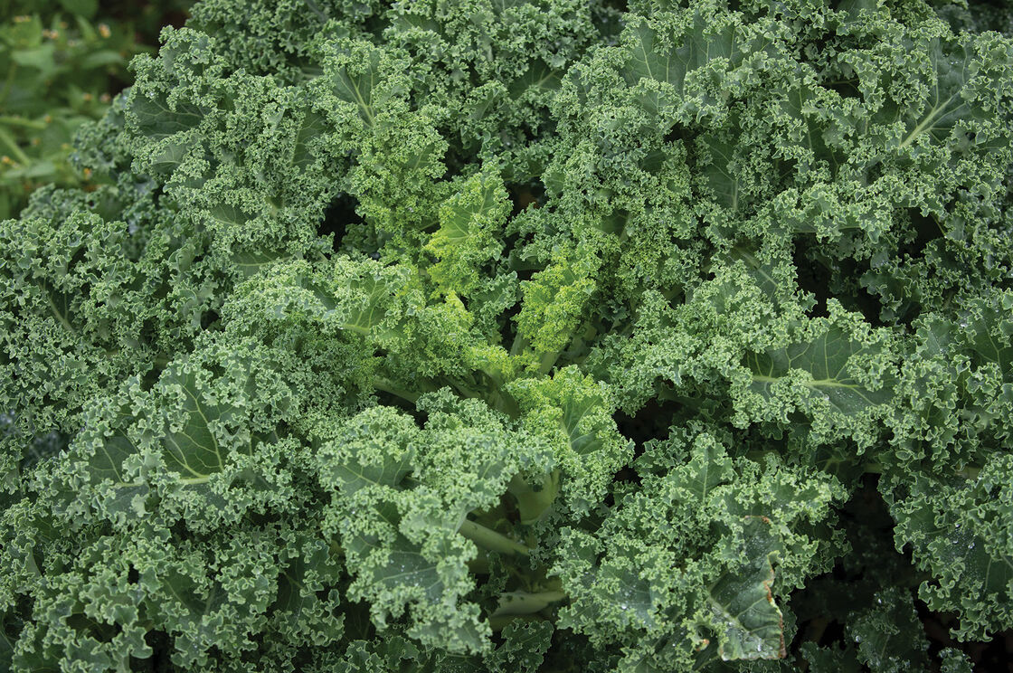
Kale, Westlandse Winter Organic
A vigorous producer with attractive blue-green leaves. Medium-tall plants have large frames and good bulk. USDA Certified Organic.
Climate: Kale prefers a fertile, well-drained soil high in organic matter with a pH range of 6.0–7.5. Avoid planting where any member of the cabbage family grew the previous year. Kale prefers cooler growing temperatures, between 55–75°F, optimum being 60–70°F, but will produce good crops under warmer, summer conditions.
Spacing: Transplant each seedling 12-18" apart.
Irrigation: 1-1 ½ inches of water per week. Soil should be moist down to an inch into the soil. Consistent moisture will produce the best quality leaves.
Fertilization: Apply side dressing of compost, fish emulsion, or fertilizer every two weeks to push the plants along in production and keep them healthy.
Matures in 32 days (baby leaves) 60 days (full-sized leaves). When leaves reach desired size, clip them off the plant using a pair pruning shears or scissors. Pick the outer leaves as needed and leave the central bud since it will grow new leaves. Store kale in an airtight bag in the refrigerator for 5-7 days. Wash when ready to use.]
https://www.johnnyseeds.com/vegetables/kale/westlandse-winter-organic-kale-seed-3566G.html
Kale is compatible with beets, celery, cucumbers, dill, lettuce, nasturtium, onions, spinach, Swiss chard, and many herbs (especially in the mint family). It is incompatible with tomatoes and strawberries.

