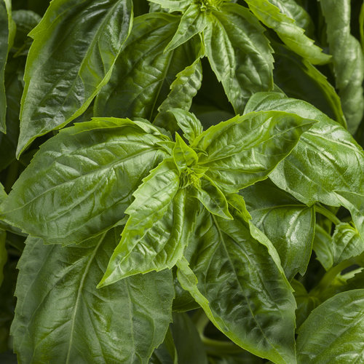
AmazelTM Basil

Between its resistance to Downy Mildew, sweet taste, hybrid vigor and seed sterility, Proven Winners’ Amazel™ Basil proves a valuable option for produce growers who are looking for something different to grow. Kevin Hurd, director of new products at Proven Winners, explains what makes this such a unique crop at:
https://www.producegrower.com/article/2018-ask-the-experts-amazing-basil-proven-winners/

The result of years of research and breeding from the University of Florida led by Dr. Dave Clark, who set out to solve the Downy Mildew issue for culinary herb growers who advised Dr. Clark that it was their number one issue with growing basil.
Very vigorous, larger 20-36" high with 12-24" spread plant bears large leaves that are more cold-tolerant than traditional sweet basil. Harvest sprays of leaves by cutting stems just above two new sprouting lateral branches to get lush regrowth.
Culture: Full sun. 6-6.5 pH. 65-72°F. ideal rooting temperatures, 65-75°growing temperatures
Annual produced by vegetative cuttings and not seed.
Irrigation: Moderate to moist
Matures to full size 4-6 weeks after transplant.

For best flavor and leaf production, harvest and or pinch regularly to promote fresh tender growth. If heavy flowering happens late in the season that will likely affect taste, but when it is actively growing new leaves and shoots it will have its best flavor. A small amount of flowering should not affect taste at all.
Additional information about the development of this variety:
UF professor works to save basil plant from disease by Anna Cappelli, November 12, 2017
http://www.alligator.org/news/article_3fcff962-c810-11e7-a8e3-071ded80de76.html
The Race to Save Sweet Basil by Adrian Higgins, published in the Washington Post, October 7, 2015
https://www.washingtonpost.com/lifestyle/home/putting-the-sweet-back-into-basil/2015/10/06/27842cb2-687b-11e5-9223-70cb36460919_story.html?utm_term=.15c1c2414f29

Basil benefits a number of other crops by simultaneously attracting pollinators and deterring destructive insects that feed on the leaves, flowers, and fruit, like beetles (bean beetles, Japanese beetles) and worms (tomato hornworms and cabbage worms).

The leafy green tops of parsnips, radishes, turnips, carrots, and beets all benefit from basil’s pest-repelling aromas. Some claim that it increases the yield of tomato plants when planted nearby.

Incompatible with cucumbers that tend to take on the flavor of what is grown nearby.

