New Member Information
VISTA Gardens is Hillsborough County's First Garden Park, organized as a 510c3 not for profit corporation under FL laws. Articles of Incorporation and Bylaws, are available for review on request.

The Board of Directors

The VISTA Board of Directors meet on the second Tuesday of each month (except July and August). Current members of the Board are: Bill West, President; Marty Kleiner, Vice President, Jennifer Grebenschikoff, Secretary; Susan Baxter-Gibson, Treasurer; Barb Mahlmeister, and Steve Taylor. More information about the Board is available at https://www.vistagardentampa.org/meet-the-members

The VISTA Board governs and makes policy, but strongly encourages operational decisions to be made at the committee level. Minutes of each VISTA Board meeting are available for review by request to the Secretary.

How the VISTA community is organized

As VISTA is a not for profit, active committee participation by every member is vital to community success. When you join VISTA, you are not only receiving a garden plot you also are committing to be an active member of the community. On membership approval, you will be asked to select and participate in one of the ten VISTA committees for a minimum of two hours a month. You are more than welcome to help more than the minimum two hours, if your time permits, and many of our members currently do.

Each committee chair has provided a description of its primary roles and responsibilities:

Communications Committee, Marc Carrillo-Perkins, Chair

The communications committee produces the monthly VISTA newsletter called “VISTA Matters.” New members should expect to begin receiving the newsletter within the first few weeks of joining. If you do not receive the newsletter, first please check your spam folder. If the newsletter is not there, please email Keri and let her know you need to be added to the distribution list. Past issues of VISTA Matters are available on our web site at: https://www.vistagardentampa.org/news

The committee also maintains the VISTA web site: www.vistagardenstampa.org, Facebook page (search and follow “VISTA Gardens”) and Instagram (search and follow “VISTA Gardens Tampa”). Please be sure to follow both if you use social media. Current garden activities, articles and events are regularly posted to those sites.

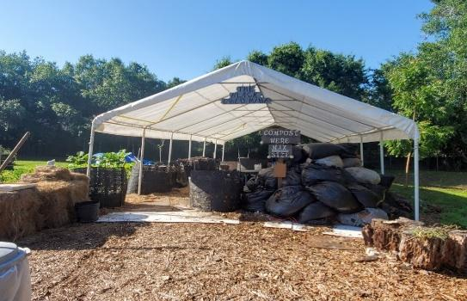
Compost Committee, M.J. Wentzel, Chair

The compost committee is responsible for producing nutrient rich soil that we fondly refer to as “black gold.” The committee requests ongoing donations from community members and also receives material from several local programs and businesses.

We accept fruit, vegetable, coffee grounds, crushed eggshells and non-diseased plant material (no weeds or plant cuttings with fungus, mildew or insect infestation). Please add material to the designated intake compost pile and cover it with leaves (available in nearby bags).

We do not compost dairy or meat products, pits, shredded paper, biodegradable bags, large roots or stick because they do not break down fast enough for our operation.

When adding plant material to our compost pile, smaller is better. For example, if you add a finished plant from your garden, please cut it into sections 12” or smaller.

Our compost piles decompose quickly because our committee turns and waters them very regularly. This process only works well when we all pitch in. If you are in good shape and like a good upper body workout, come help turn the pile! At a minimum, please plan to join the committee at least once each year to help turn and/or sift. (Naturally, do not feel pressured to do this if there are physical limitations that prevent your participation)

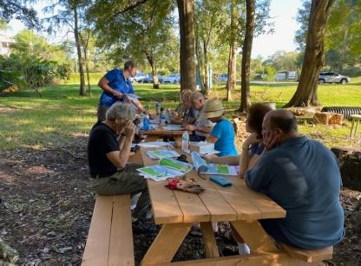
Education Committee, Barb Mahlmeister, Chair

If you don't know how to 'garden,' neither did most of us when we started VISTA. We offer many classes on how to start plants from seeds, how to fertilize, when to pick your crop, how to trim and how to replant during different seasons to name a few. Urban Roots, Whitwam Organics and the UF IFAS program offer classes to help you learn to get the most from your garden experience.

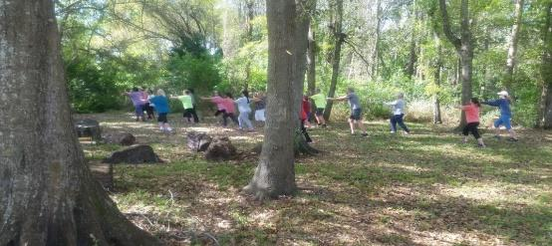
We also offer classes on other topics such as how to attract birds to your yard (from Wild Birds Unlimited), butterfly gardening, how to get the most from your fresh herbs and nutrition lectures. Yoga and Tai Chi classes are available when the weather is tolerable. The education committee welcomes topic and speaker suggestions. Classes are held between October and May.

Finance Committee, Susan Baxter-Gibson, VISTA Treasurer and Chair

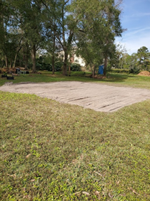
VISTA Gardens does not receive operating funds from the County, although the County owns the property and will sometimes help us with capital projects such as the future pavilion (see photo).

The garden is required to file a short tax form every year with the IRS, but we are a tax-exempt organization. As a 501(c)3 charitable organization, donations to VISTA are tax deductible and very welcome.

The garden has an annual operating budget and it runs around $15,000. All of the accounting and related financial reporting functions are provided through donated services by a member.

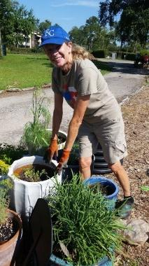
Garden Committee, Roberta Owens, Chair

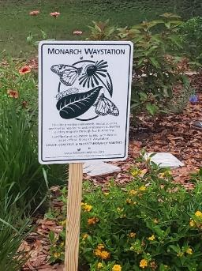
The garden committee encourages full participation of VISTA members in upkeep of the gardens, including tending their own raised garden beds and assisting with common areas – container herb garden, experimental garden, Monarch Waystation gardens, pond, Little Free Library, fledgling fruit trees, etc.

In collaboration with the Education Committee, we plan and present learning experiences for member gardeners, VISTA Social members and, in some cases, the general public.

We coordinate tours and learning experiences for community groups.

We work to sustain and continually develop a natural and aesthetically pleasing environment, focusing on native plantings.

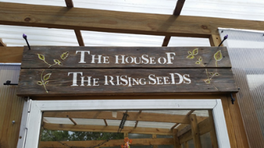
House of the Rising Seeds (HRS) Committee, Chris Schelin, Chair

We seasonally grow seedlings for members to transplant in their garden beds. We request a donation of $2.00 - $4.00 per seedling to cover the cost of seeds, soil, nutrients, containers. Additionally, we provide small seed packets for directly sown plants (e.g., radishes, beets), with a requested donation of $0.50 - 1.00 per packet. We source our organic seeds carefully to ensure they are of the highest quality.

Our seeding aligns with the growing seasons, including warm season (e.g. peppers, eggplants) plants and cool season (lettuce, peas) plants. Quantities produced are based on past years’ experience. Watch the newsletter, VISTA Matters, for announcements of available seedlings.

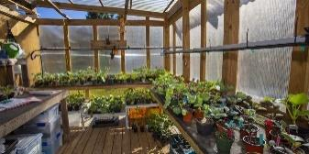
We post plant and growing information on the VISTA website: https://www.vistagardentampa.org/vegetable-fact-sheets. If there is a vegetable that a member wants but our committee is not currently offering, members can seed and tend themselves. This way they don’t need to buy from a big box store.

We will help you plan your garden space, so that you have room for cool season plantings and more continual harvests. We welcome new members to the committee. The best way to learn about growing seedlings is through hands-on experience.

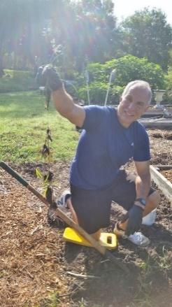
Infrastructure Committee, Marty Kleiner, Chair

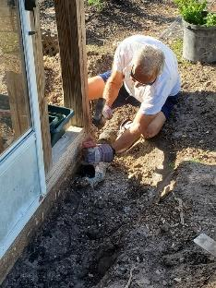
VISTA Gardens is “off the grid,” meaning we have no County water or electricity. All the water comes from a well powered by solar electricity. “Back up” water is available in rain barrels beside the shed, in case there is no water in our tanks (or at the hose near your garden plot.)
VISTA Gardens has no paid employees and therefore entirely depends on community member support and volunteers. We need everyone’s help to keep the weeds pulled, garden clean and with special projects as they arise.

VISTA Gardens has no trash or recyclable pickup. Members periodically take the garbage and recyclables home and throw it in their home trash containers. Please feel free to take full trash bags home with you if you see one is ready for disposal.

Marketing, Steve Taylor, Chair

This committee works to promote VISTA Gardens in the County and seeks fundraising opportunities, like the bi-annual Anthony’s Coal Fired Pizza “dining giveback.” The committee also works to identify grant funding sources and grant writing. If you have experience in fundraising and grant writing, your assistance on this committee is welcome.

Membership Committee, Rolfe Evenson, Chair

Responds to ongoing membership inquiries and provides tours to prospective members. The committee maintains a current garden map that shows member assignment to each plot.

The committee also manages the membership renewal process and is responsible for notifying and processing renewals, plus maintains records of applications and contact information. The committee also collaborates with the Garden Committee on New Member Orientation and introducing new members to their selected committees.

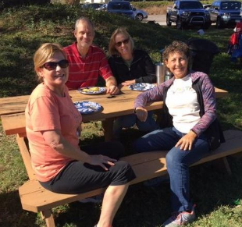
Social Committee, Laurie Kleiner, Chair

Throughout the year, the social committee provides opportunities for people to gather socially and get to know their garden buddies. Examples of successful activities include potluck gatherings, social bike rides, happy hours and local restaurant outings.

Please feel free to join the social committee and help plan future events.

Volunteer Committee, Yvonne Scalise, Chair

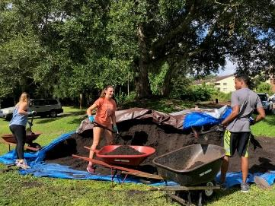
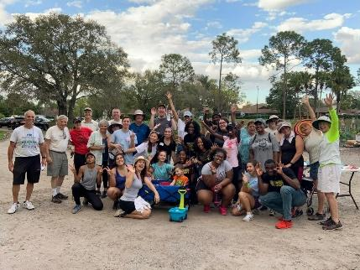
The volunteer committee welcomes groups of high school students to the garden on most Saturdays to help us with general garden maintenance, and them with gaining their required volunteer hours. In addition, local colleges and community groups sometimes volunteer for special projects.

This is a great committee for anyone who enjoys working with groups of enthusiastic people looking to make a difference in their community.

Membership

As a new member you agreed to the following commitments when you signed and submitted your membership application:

Commitments

- Learn and practice sustainable and organic gardening. Following are resources community members find helpful:
- Month-by-month planting and garden maintenance guide: http://edis.ifas.ufl.edu/ep450
- Vegetable Gardening Guide: https://7f72b1de-8f7d-41a1-80dd-4418194fc079.filesusr.com/ugd/834747_25b8ba5c94bc440abd8630a3b4573543.pdf
- Additional References and resources are available at: https://www.vistagardentampa.org/learn

- To observe reasonable safety precautions and report any unsafe conditions or activities to the Board or the relevant committee chair. https://www.vistagardentampa.org/meet-the-members

- To protect the property. Each time you leave the garden, please ensure the gate, shed and equipment are locked and water valves are closed. If you arrive at the garden and observe these areas are unlocked, or water valves are open, please notify the Board of Directors (email leahgator@gmail.com).

- To be responsible for the safety and behavior of all guests and those I authorize to tend my plot.

- VISTA Gardens believes in the honor system. You commit to being a good neighbor and should expect your neighbors to be good to you. You commit to keeping your garden space (inside and outside) free from weeds, pests and disease and will return all shared tools to their appropriate place in better condition that I found them.

- I understand that it is necessary to close down and cover my plot for the summer months (Mid-June through Mid-August) and assist in maintaining the pathways and other common areas throughout this time. If I want to grow summer specific crops, I will make arrangements with the Garden Committee.

- I will not make changes or alterations to the community property (area outside the raised garden plots) without Board approval.

I will participate, support, or lead:
- in assisting with the physical work of maintaining common areas, amenities, infrastructure, and any vacant plots
- creating and maintaining a beautiful garden consistent with community at large
- joining and supporting a committee or proposing to the Board and implementing a Board-approved independent project
- assist differently-abled gardeners as opportunities arise
- start my garden within two-weeks of joining (or Fall season opening) and understand I forfeit use of my plot and membership fee if I do not start the garden, or if my plot falls into neglect requiring others to tend to weeds or plant disease created by inaction.

Failure to comply with any of these commitments can result in loss of raised garden bed and VISTA membership.

“We get out of it what we put into it. Gardening requires research, determination, and patience (especially with Florida’s different growing seasons and challenges).” Marc Perkins-Carrillo, Chair-Communications Committee, member since 2019.

Welcome to the VISTA Community, we are glad to have you here. Happy Growing!

