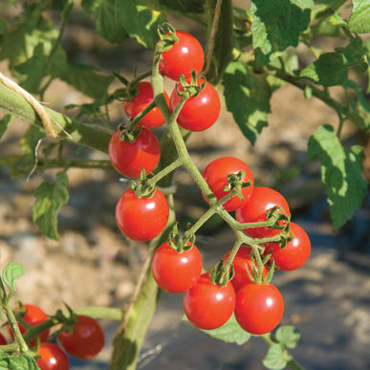
^{Jasper Organic (F1) Tomato}
Round, 2-3" fruit with pleasantly chewy texture and sweet, rich flavor. Plants are extra vigorous and tall, staying healthy for a long picking period. Intermediate resistance to early blight, Septoria Leaf Spot, and late blight. Crack and rot resistant. AAS winner.

Culture: Medium-rich soil with pH 6.0–6.8 preferred.

Spacing: Transplant seedlings 24 inches apart so that soil level is just below the lowest leaves. Indeterminate variety: Train to a vertical support and prune for best results.

Irrigation: Water in early morning, ideally. Always avoid splashing water on the tomato leaves. Tip: Mark your calendar 55 days from the day of transplant, reminding yourself to reduce watering (by half) to concentrate sugars.

Fertilization: Ensure abundant soil phosphorus for early high yields. Too much nitrogen causes rampant growth and soft fruits susceptible to rot. Abundant soil calcium prevents blossom end rot.

Maturity/Harvest: 60 days from transplant

Tomatoes are compatible with basil, beans, chives, cucumbers, garlic, lettuce, marigolds, nasturtium, onion, parsley, and rosemary; all of which help control pests.
Tomatoes are incompatible with broccoli, cauliflower, corn, and dill. Carrots grown with tomatoes will have good flavor but stunted roots.

