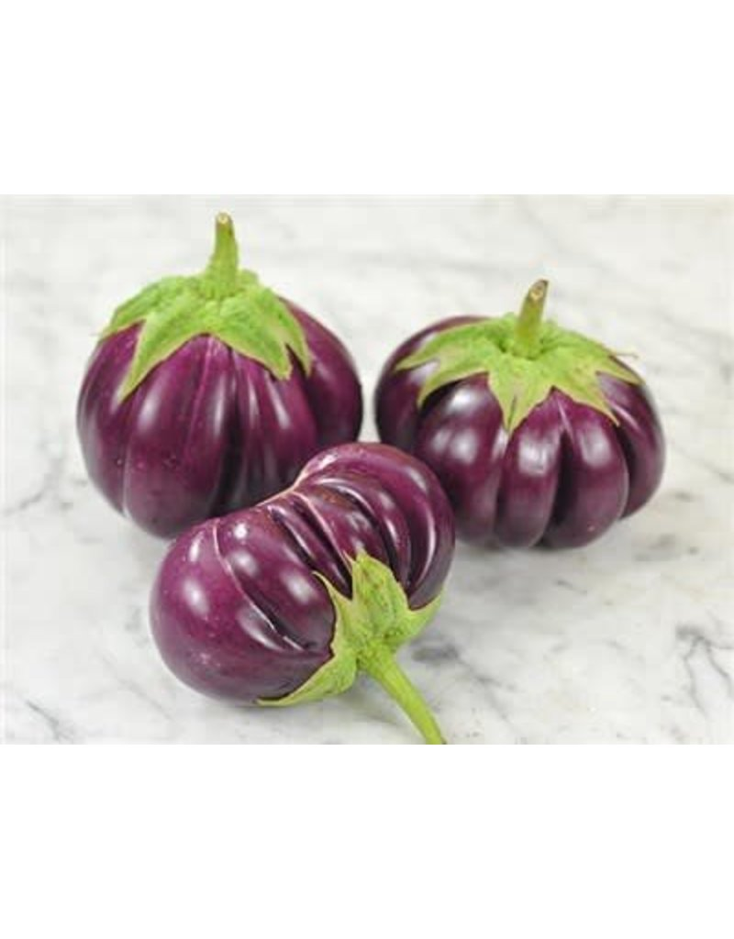
PURPLE RIBBED EGGPLANT
This variety produces lovely, highly ribbed, plum-purple fruit that has a delicious, strong eggplant flavor. Fruit varies from tennis to softball sized. Very productive and unique!

Climate: Eggplant is very tender perennial, most often grown as an annual, requiring 100 to 140 warm days with temperatures consistently between 70° and 90°F to reach harvest. Transplant outdoors in full sun when soil is at least 55-60 degrees F.

Spacing: 18-24 inches apart.

Irrigation: Evenly moist but not soggy soil. Try not to allow the soil to dry out.

Fertilizer: Use a good starter fertilizer to support root and leaf development. Once fruit begins to develop, switch to a phosphorus-rich fertilizer like bone meal to encourage healthy fruit development. At this point if over fertilized with nitrogen, they will grow excessive foliage and produce less fruit. Eggplants require moderate fertilization. Typically, fertilizing two times during the growing season is sufficient.

Matures 70 days after transplant.

Seed source:
https://www.rareseeds.com/store/vegetables/eggplant/thai-purple-ribbed-eggplant

Eggplant is a compatible neighbor with and benefits from growing alongside many plants. It has no incompatibility issues! Read more about this in the following blog, that will surely provide inspiration for planning your garden.
https://insteading.com/blog/companion-planting-for-eggplant/

