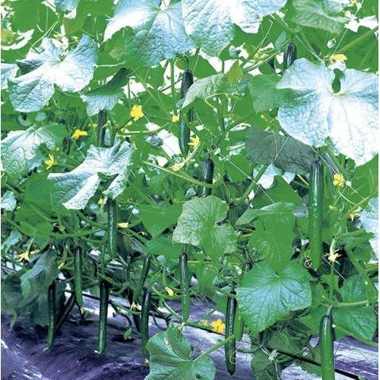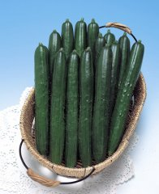
Summer Dance Cucumber

Best known for its extremely uniform fruit, this hybrid grows vigorously and delivers a high yield from its many lateral vines. The mild tasting, deep green fruit are near perfect—straight with fine white spines on their glossy skin. They grow to about 9" long and more than 1" in diameter. Highly resistant to downy mildew and powdery mildew, it has an intermediate resistance to corynespora blight and target spot. This variety is suitable for open field growing and has a monoecious flowering habit (plant produces both male and female flowers.)

Culture: Ideal soil temperature is 78-86˚F. Ideal soil pH between 6 and 7. Optimum growing temperatures are 75°F daytime and 60 F at night.

Spacing: Sow seeds 1" deep, 2-4" apart. Thin to 10-12"

Trimming and Staking: Train to climb a vertical support for better air circulation, straighter fruits and ease of harvest.

Keep the primary vine and support with trellis. Each node on the vine has a tendril (important for attaching to trellis and/or stake), a fruit, a leaf (important for photosynthesis), and a growth point. Prune growth points for improved plant health and production.

Helpful video on pruning growth points: https://www.youtube.com/watch?v=TGkFJh5bKGg

Irrigation: Keep soil moist.

Fertilization: Liquid fertilizers low in nitrogen and higher in phosphorus and potassium fertilizer are ideal. (Excessive nitrogen produces excess foliage at the expense of blossoms and fruiting.) Once established and blooming, discontinue fertilizing.

Maturity: Harvest in 60 days.

https://www.kitazawaseed.com/seed_391-23.html

Plant beside beans, Brassicas, celery, corn, dill, kohlrabi, lettuce, onion, peas, radish, and tomatoes. Avoid planting near potatoes and sage. Both corn and sunflowers can act as a trellis for cucumbers to good effect. Dill will help cucumbers by attracting predatory insects, and nasturtiums will improve the flavor and growth of cucumbers.
https://www.westcoastseeds.com/blogs/garden-wisdom/companion-planting

