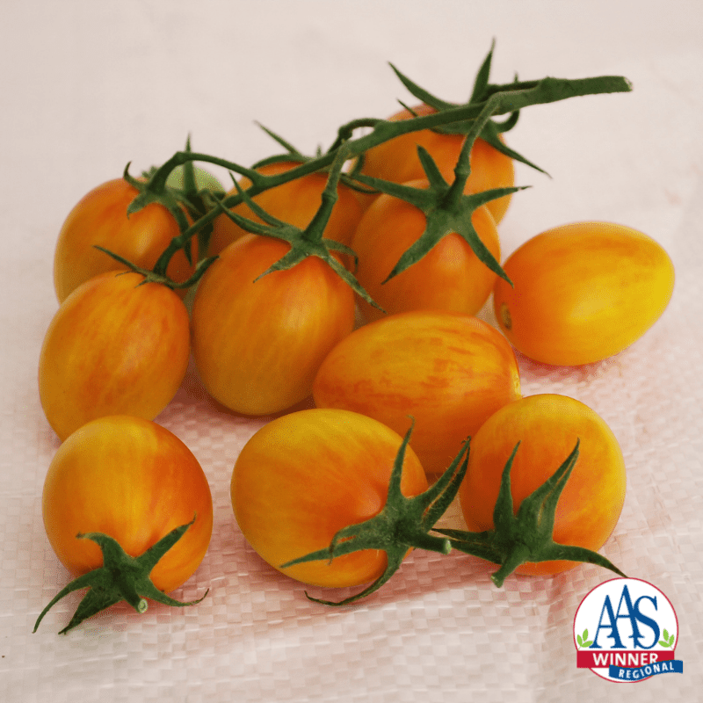
^{Sunset Torch (F1) Tomato}
2022 All-American Selections (AAS) Winner sets small "perfect" flowers followed by uniform 2-inch plum-shaped fruits, weighing about 1 ounce each, having a moderately firm texture. A mildly sweet, fruity flavor makes for particularly good for snacking.

Blossoms and fruit continue to develop as the vine grows, so, it bears an impressive amount fruit over the course of a season, typically 250 to 300 cherry tomatoes per plant. Sunset Torch has an attractive open habit of easy-to-harvest trusses and is suitable for a container.

Culture: Moist, humusy [sic], deep, fertile loamy soil. Sensitive to cold, so protect plants with cover if temperatures are expected to dip below 50°F. Mulching helps to moderate soil temperature and to maintain soil moisture.

Spacing: Transplant seedlings 24 inches apart so that soil level is just below the lowest leaves. Indeterminate variety: Train to a vertical support and prune for best results.

Irrigation: Water in early morning, ideally. Always avoid splashing water on the tomato leaves. Tip: Mark your calendar 70 days from the day of transplant, reminding yourself to reduce watering (by half) to concentrate sugars.

Fertilization: Ensure abundant soil phosphorus for early high yields. Too much nitrogen causes rampant growth and soft fruits susceptible to rot. Abundant soil calcium prevents blossom end rot.

Disease Resistance: High disease resistance to ToMV, Verticillium Wilt Va/Vd, Fusarium Wilt Races 1 and 2 and intermediate resistance to TYLCV.

Maturity/Harvest: 75 days from transplant

Seed source: https://parkseed.com/sunset-torch-tomato-seeds/p/52936-PK-P1/

https://all-americaselections.org/product/tomato-sunset-torch/

Tomatoes are compatible with basil, beans, chives, cucumbers, garlic, lettuce, marigolds, nasturtium, onion, parsley, and rosemary; all of which help control pests.
Tomatoes are incompatible with broccoli, cauliflower, corn, and dill. Carrots grown with tomatoes will have good flavor but stunted roots.

