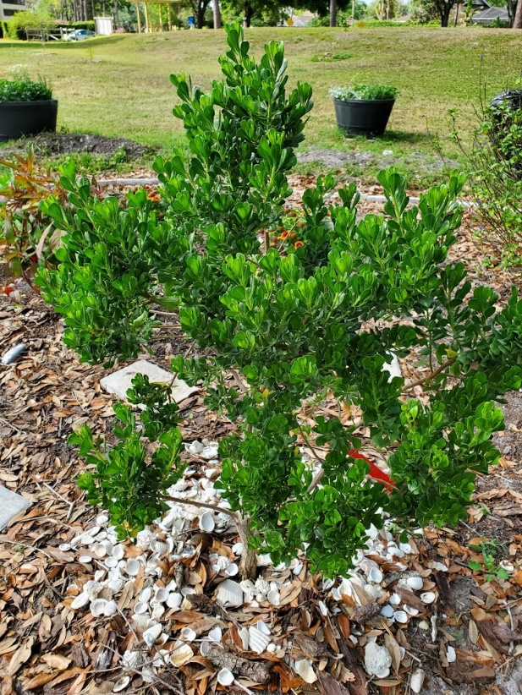
Dwarf Salt Bush
Baccharis dioica

Also called Broombush Falsewillow, this long-lived perennial is a medium compact shrub 4 ft. in height and spread. The leaves are attractive and unique recurved bluish or gray green in color. It produces creamy white flowers in the late summer and fall that attract pollinators and provide nectar for butterflies. It is a rare plant in the wild, previously known from the Florida Keys as well as the Florida panhandle. This is a very easy growing small shrub with high salt air tolerance, cold tolerance, and drought tolerance.
https://www.wilcoxnursery.com/?s=Dwarf+Saltbush
Nectar attracts butterflies.
https://www.fnps.org/plant/baccharis-dioica

