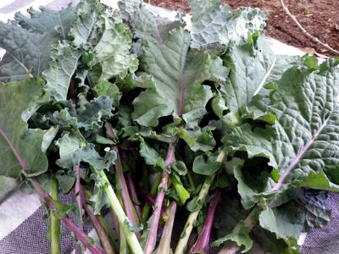
Lacinato Rainbow Mix Kale
Lovely blue-green leaves, plus shades of red and deep purple (most vivid in cool weather) that were created by crossing classic Lacinato with Redbor to create this hardy kale.
Culture: Grows best in well-drained soil with compost and available nutrients like nitrogen. Avoid planting where any member of the cabbage family grew the year before.
Spacing: Transplant each seedling 12” apart. Grows 18-36" in height and 18" in width.
Irrigation: 1-1 ½ inches of water per week. Soil should be moist down to an inch into the soil.
Fertilization: Apply side dressing of compost or low nitrogen fertilizer every two weeks to push the plants along in production and keep them healthy.
Mature in 65 days. Collect young leaves anytime. Clip oldest leaves when less than 12" long for tender leaves and best flavor.
https://www.southernexposure.com/products/lacinato-rainbow-mix-kale/
Kale is compatible with beets, celery, cucumbers, dill, lettuce, nasturtium, onions, spinach, Swiss chard, and many herbs (especially in the mint family). It is incompatible with tomatoes and strawberries.

