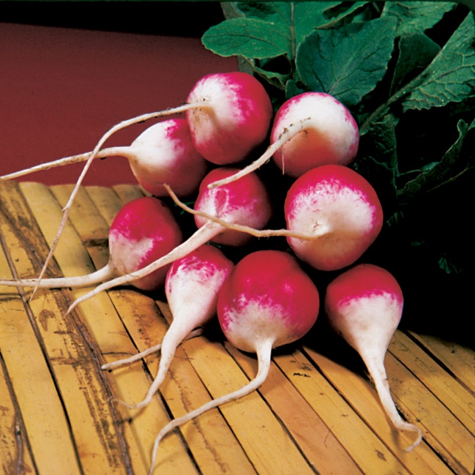
Radish Sparkler, Organic
Sparkler recently staged a big comeback, and now it's available as certified organic seed. Delightful little two-tone jewel for quick harvest, mild peppery bite, and terrific plate appeal. The shading from brightest scarlet to pure white is dotted with merry flecks, and the size of the fruit ranges from 1 to 1½ inches, with a wide, long white root trailing from the end. The plant is columnar, reaching about 6 to 8 inches tall and up to 6 inches wide.

Culture: Before planting, add compost to the soil, making it as loose, rich, and moist as possible. Radishes cannot withstand much heat.

Spacing: Sow seeds in moist soil, 1/4 - 1/2" deep, 1" apart, in rows 12" apart. Thin to 4-6" apart when they are a week old and plant a new group of seeds! Planting successively every week allows for continuous harvesting.

Irrigation: If plants do not receive one inch of rain weekly, water deeply. Drought stress can cause the roots to develop poor flavor and a tough texture.

Fertilization: Radishes do not require additional fertilization after they are planted. Be careful not to use nitrogen-rich fertilizers near radishes, as you will prompt leaf growth at the expense of radish root.

Maturity: 25 days.

https://parkseed.com/organic-sparkler-radish-seeds/p/05875-PK-P1/

Plant radishes near beans, beets, celeriac, chervil, cucumber, lettuce, mint, parsnip, peas, spinach, squash, and tomatoes. Avoid planting near potatoes.

