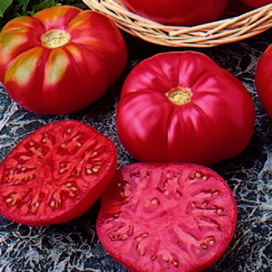
Caspian Pink, Hybrid
The first tomato to beat Brandywine in taste tests! We all love Brandywine - that wonderful Amish treasure generally considered to be the world's finest flavored tomato. But in our California trials, heirloom Caspian Pink has beaten Brandywine for several years! Originally grown in Russia in the area between the Caspian and Black Seas.

Climate: Transplant when soil temperature is at least 60°F. This tomato thrives in 6-6.5 soil pH.

Spacing: Space seedlings 24 inches apart. Transplant so that soil level is just below the lowest leaves. Train to vertical support or set cage into ground immediately after transplanting.

Irrigation: Keep soil evenly moist. Water early in the day if the top 1 to 2 inches of soil feels dry to the touch. Never allow the soil to become either too soggy or too dry. Uneven moisture levels can cause cracked fruit or blossom end rot.
Fertilizer: Granular Nature Safe 5-6-6 and Blood Meal, along with Compost Plus, Micros Plus, and Capacity Plus, used at VISTA at the beginning of the Fall season are good starter fertilizers. Continue regular feeding with reduction in nitrogen, using a fertilizer with more phosphorus and potassium that also contains calcium. Totally Tomato recommends NPK of 4-6-8.
Matures 80 days after transplant.

https://www.totallytomato.com/product/T00170/85

https://gardeningsolutions.ifas.ufl.edu/plants/edibles/vegetables/cherry-tomatoes.html

Tomatoes are incompatible with broccoli, cauliflower, corn, and dill. Carrots grown with tomatoes will have good flavor but stunted roots. Compatible with basil, beans, chives, cucumbers, garlic, lettuce, marigolds, nasturtium, onion, parsley, and rosemary; all of which help control pests.

