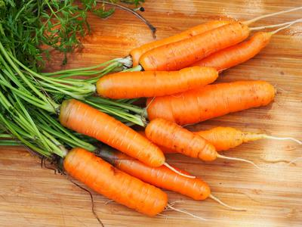
Scarlet Nantes
A garden favorite appreciated for its fine texture, mild flavor, and very small core. Cylindrical (not tapered) roots 6½ in. long, 1-1½ in. at the shoulder.

Culture: Loosen soil to a depth of 9"and work in organic matter, such as leaf mold or peat moss to provide good drainage, loose structure, and adequate moisture-holding capacity.

Spacing: Sow seeds ¼ inch deep, 3 seeds per inch. Cover seeds with fine, light soil (they need light to germinate over the next 7-21 days). When carrot tops reach 2-inches in height, gently thin them to be 3" in rows 12-16" apart. Use a small scissor to cut rather than pull, so that you do not disturb neighboring carrot roots.

Irrigation: Carrots like good drainage and regular watering, although the soil should be moist and not saturated. It is important not to allow soil to dry out. After foliage is several inches high, add organic mulch to conserve moisture. Extreme fluctuations of soil moisture between dry and wet conditions may cause cracking of the roots.

Note: When the tops of the carrots begin to emerge form the soil, cover them with soil or organic mulch to keep them tender. Keep weeds under control to avoid carrots from becoming stunted.

Fertilization: When carrot tops are 3" high, apply fertilizer that is low in nitrogen and higher in potassium. Excessive nitrogen results in carrot roots cracking and splitting.

Maturity: 70 days. Best quality roots are no larger than 1½" in diameter.

https://www.southernexposure.com/products/scarlet-nantes-coreless-nantes-half-long-carrots/

Carrots are compatible with beans, Brassicas, lettuce, onions, peas, peppers, pole beans, radish, and *tomatoes.

Avoid planting with dill, parsnips, and potatoes.

Generally speaking, it is a good idea to keep some space between root crops so they don’t compete for available phosphorus.

Planting carrots with aromatic herbs or onions may repel the carrot fly and its maggot. Chives also benefit carrots. Other compatible herbs include rosemary and sage.

*Carrots planted near tomatoes may have stunted roots, but will have exceptional flavor.

