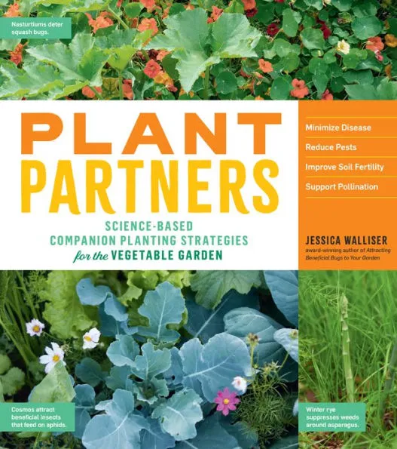
Jessica Walliser's book, “Plant Partners: Science-Based Companion Planting Strategies for the Vegetable Garden” (Storey Publishing, 2020) might be the perfect gift for your favorite garden mate.
Companion planting has a long history of use by gardeners, but the explanation of why it works has been filled with folklore and conjecture, often at the expense of sound science. Learn the emerging information from research about how plants interact with and influence each other, from the chemical signals they pass back and forth to the thread-like fungi that help them access otherwise unavailable nutrients. It offers specific plant partnerships that growers can use to solve common gardening problems, improve soil health and weed control, decrease pest damage, and increase biodiversity, resulting in real and measurable impacts in the garden.
Here are some excerpts that might interest VISTA gardeners:
Radishes help fight the flea beetles on new tomato transplants. A radish trap crop can also protect young eggplants and peppers. Pak choi works as a decoy, too, but if you use radishes instead, you can salvage the roots to eat.
Nasturtiums sown among zucchini may limit the damage done by squash bugs.
Interplant! Rather than replicating old-style rows of a farm field in your vegetable garden, Jessica Walliser recommends a modern, vibrant jumble of vegetables, fruits, herbs and flowers.
The goal, she writes, is to create a habitat that supports beneficial insects, which means avoiding pesticides and other chemicals that kill indiscriminately.
Sweet Alyssum grows on organic lettuce farms in California, in strips alternated with lettuce to enhance biological aphid control.
Cosmos help against aphids, too, particularly around brassicas like broccoli and cauliflower. And so do other aster family members, including sunflowers, rudbeckia, coreopsis and zinnias, by attracting beneficial predatory insects.
Basil! “I was so pleased to find out that the power of basil was pointed out in various studies,” said Ms. Walliser, who plants it liberally in her home garden. Studies show that it can help against thrips that stunt tomato plant growth and cause early fruit drop and may limit egg laying by adult moths whose larvae are the all-too-familiar (and voracious) tobacco and tomato hornworms. It also works against yellow-striped armyworm moths.
There is seldom a season in the vegetable garden without a pest infestation of some kind. As organic gardeners, Ms. Walliser recommends that we develop a realistic tolerance for some pest pressure.
She also urges that we do our part by practicing good garden hygiene, removing faded or diseased foliage as it appears.
And please, she says, give everybody enough room. Make a garden plan and be strategic. Plants, including their companions, compete for resources like water and nutrients, and there can be too much of a good thing.
Here is a chart to guide use of information from this book when planning and planting your garden:
Tomatoes
Wild or New Zealand white clover with tomatoes and eggplants | Living mulch to reduce aphids; host for aphid predators and parasitoids | p. 57
Okra with currant tomatoes [Everglades] | Natural trellis - 1 tomato plant per each okra | p. 88
Basil | Deter thrips, limit egg laying behavior of hornworms | p. 112, p. 118
Thyme as living mulch + Basil interplanted | Reduce egg laying of Yellow-Striped Army Worm | p. 119
Pak Choi interplanted among tomatoes, eggplant, peppers, broccoli, cabbage, kale | Trap crop to lure flea beetles | p. 106
Eggplants
Wild or New Zealand white clover with tomatoes and eggplants | Living mulch to reduce aphids; host for aphid predators and parasitoids | p. 57
Dill and cilantro | Control CO Potato Beetle | p.152
Pak Choi interplanted among tomatoes, eggplant, peppers, broccoli, cabbage, kale | Trap crop to lure flea beetles from nightshades and Cole crops | p. 106
Peppers
Onions with peppers | Deter Green Peach aphids | p. 110
Black-eyed peas, Cowpeas with peppers | Draw moisture to surface, reduce weeds, fix nitrogen | p. 40, p.60
Pak Choi interplanted among tomatoes, eggplant, peppers, broccoli, cabbage, kale | Trop crop to lure flea beetles | p. 106
*Cole crops
Onions, marigolds, white clover | Reduce egg laying of onion flies, cabbage root maggot flies | pp. 121-122
Sage, dill, German chamomile, hyssop | Deter egg laying of cabbage worms and provide nectar source for beneficial insects that prey on cabbage worms | p. 117
Cosmos, Black eyed Susan | Control aphids | p.155
Broccoli, Collards, Kale  Mustard Greens  Pak Choi | Mustard Greens planted several feet away to lure Harlequin bugs away from broccoli, collards, kale  Interplant Pak Choi as trap crop to lure flea beetles | p. 107  p.106
Broccoli, Brussels, Cauliflower, Kale  with Crimson Clover | Suppresses weeds, provides habitat for beneficial insects – cut regularly to form thick, low mat | p. 54
Chinese cabbage with green onions | Controls flea beetles | P. 112
Collards with calendula | Reduces aphids | p. 114
Collards, Chard, Kale, Spinach with  edamame | Fix nitrogen when a few weeks old and continue being available for several months | p. 42
Squash
Small pumpkins (e.g. “Jack Be Little”) with sunflowers | Natural trellis | p. 72
Zucchini with nasturtiums | Reduce squash bugs | p. 110
Lettuce
Lettuce with Sweet Alyssum | Food source for beneficial syrphid flies and parasitic wasps to manage aphids | p. 156
Lettuce/Greens with dill, fennel, cilantro | Lure beneficial insects to prey on aphids | p. 152
Peas
Sugar snap peas with lettuce | Provide necessary nitrogen and shade that may prolong harvest | p. 41
Vegetables prone to non-beneficial caterpillars may benefit from dill, cilantro, fennel, sage, marjoram, oregano, lemon balm, and/or thyme to lure parasitic wasps and support them with nectar. P. 155
* The UF/IFAS Vegetable Production Handbook of Florida chapter on cole crops lists twelve: broccoli, cabbage, cauliflower, Chinese broccoli, Chinese cabbage, Chinese mustard, kohlrabi, oriental radish, collards, kale, mustard, and turnips. https://gardeningsolutions.ifas.ufl.edu/plants/edibles/vegetables/cole-crop-confusion.html
Companion planting information and charts abound,
including this one from Farmer’s Almanac.

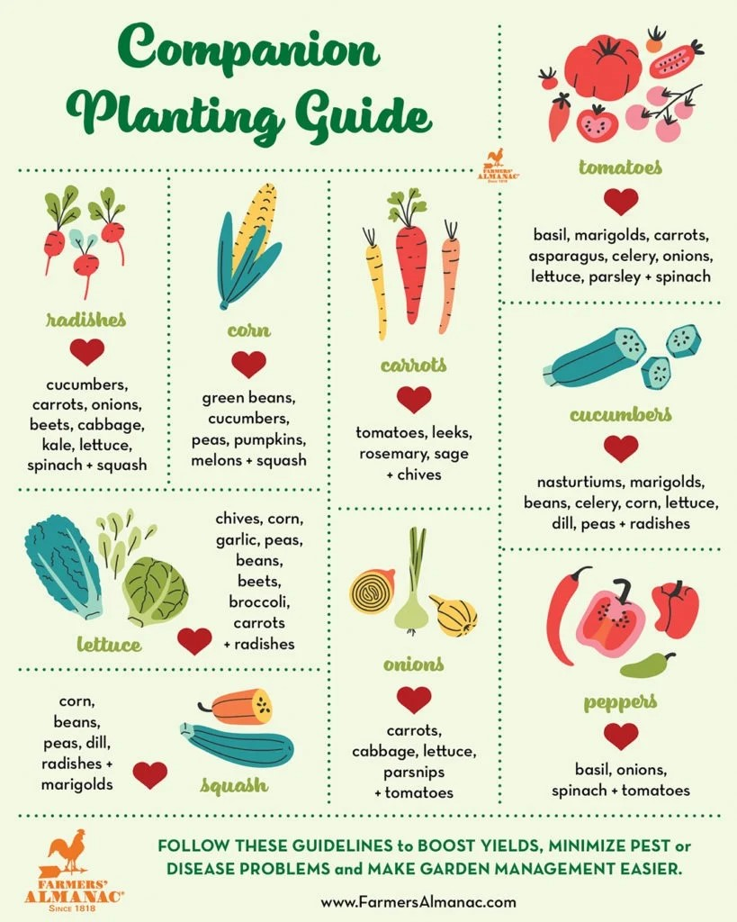

Lastly, savvy VISTA gardeners open files attached to the Vegetable Information Sheets on our website to find compatible and incompatible plants for the vegetables they grow. https://www.vistagardentampa.org/vegetable-information-sheets
For example, many VISTA gardeners grow Burgundy Broccoli. When they click the relevant “Download File” button at: https://www.vistagardentampa.org/broccoli-and-broccolini
they find helpful information about planting, irrigating, fertilizing, and harvesting their broccoli plant, as well as the following information about companion plants:

Compatible plants include carrot, celery, cucumber, lettuce, radish, shallot, spinach, and Swiss chard. Because broccoli is a notorious calcium-hog, plants that require little calcium (e.g. beets, nasturtiums, marigolds) are good companion plants.
Incompatible plants include peppers, mustard greens, pole beans, lima beans, snap beans, squash, and strawberries. Since broccoli is a heavy feeder, other heavy-feeding plants are not good companions (cantaloupe, pumpkin, sweet corn, and watermelon).
Happy gardening!
