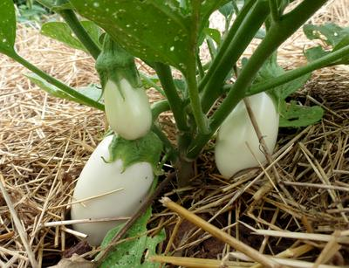
White Beauty Eggplant
Three-foot plants with 6-inch-long fruits that are 2-3 inches in diameter with some variability in fruit shape. Good flavor. Hardy and productive for the South and other hot, humid areas.

Spacing: 20 inches between plants, 30 inches between rows.

Irrigation: Evenly moist soil. Do not over water or allow the soil to dry out.

Climate: Transplant outdoors in full sun when soil is at least 75 degrees F.

Fertilizer: Once fruit begins to develop, apply a phosphorus-rich fertilizer like bone meal to encourage healthy fruit development. Too much nitrogen will produce lush foliage and few fruit. A balanced tomato/vegetable fertilizer works well for continued, regular feedings.

Maturity/Harvest: 70 days

Seed source: https://www.southernexposure.com/products/white-beauty-eggplant/

Eggplant is a compatible neighbor with and benefits from growing alongside many plants. It has no incompatibility issues! Read more about this in the following blog, that will surely provide inspiration for planning your garden.
https://insteading.com/blog/companion-planting-for-eggplant/

