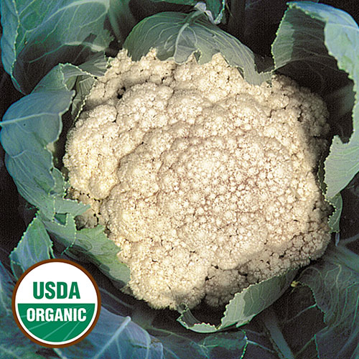

Cauliflower, Early Snowball

Smooth 6-7" heads of tightly formed white curds are solid, crisp, and tender. This variety is well-suited to being eaten raw, baked, roasted, or steamed. Can be overwintered for an early crop in warmer regions.

Culture: Plant in well-draining soil that is rich in organic matter. Ideally grow when temperature is consistently cool (60°F).

Spacing: 24 inches between plants

Irrigation: Make a small depression around the stalk of seedling to help water reach directly to the root system as it develops. Water regularly with 2 inches of water each week; even with normal rainfall, this usually requires supplemental watering.

Fertilization: Feed with lower nitrogen fertilizer, such as 5-10-10, when transplanting and every four weeks thereafter.

Maturity: 60-85 days from transplant. Monitor closely leading up to harvest. Opening buds on the head result in a bitter taste and rice-like consistency instead of desirable tight cauliflower. Harvest when it is dry to prevent curd from molding in storage.

https://www.seedsavers.org/early-snowball-organic-cauliflower

Note: Tying leaves around heads to blanch is not necessary, but the practice helps prevent yellowing of the creamy white head, called a curd. If you blanch, simply fold a few plant leaves and clip (or tie with twine) to cover the cauliflower curd when it is the size of your fist (2-3 inches in diameter).

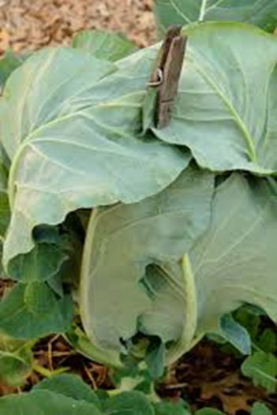

Compatible with beans, beets, broccoli, Brussel sprouts, celery*, chard, chamomile, oregano, onions, peas, rosemary, sage, spinach, sunflower, tomatoes.

Incompatible with strawberries and rue.

*Celery is a great friend to plants in the brassica family, making them amazing cauliflower companion plants. The aromatic leaves of the celery plant keep the white cabbage moth from infiltrating the garden bed.

https://www.kellogggarden.com/blog/gardening/gardeners-guide-to-cauliflower-companion-plants/

