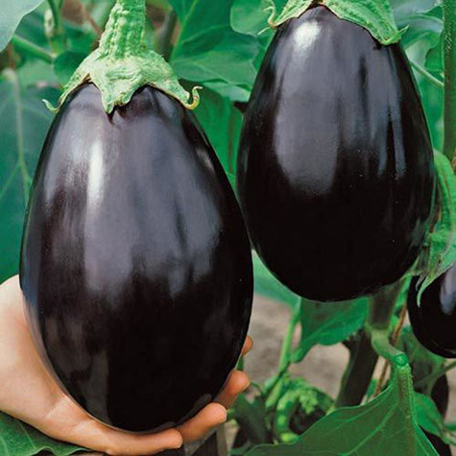
Black Beauty Eggplant

An heirloom variety, it bears classically shaped, glossy, purple-black fruits that are delicious grilled, baked, and in stir-fries.

Climate: Eggplant is very tender perennial, most often grown as an annual, requiring 100 to 140 warm days with temperatures consistently between 70° and 90°F to reach harvest.

Spacing: 24 inches apart.

Irrigation: Evenly moist but not soggy soil. Try not to allow the soil to dry out.

Fertilizer: Once fruit begins to develop, switch to a phosphorus-rich fertilizer like bone meal to encourage healthy fruit development. At this point if over fertilized with nitrogen, they will grow excessive foliage and produce less fruit. A balanced tomato/vegetable fertilizer (including calcium) works well for continued, regular feedings. Fertilizing twice during the growing season is typically sufficient for eggplants.

Matures 80 days after transplant. Keep well picked to keep plants producing. Small fruits have the best eating quality. Fruits are ripe when the skin appears glossy and fruit is resilient to thumb pressure.

Seed source:
https://www.southernexposure.com/products/black-beauty-eggplant/

Eggplant is a compatible neighbor with and benefits from growing alongside many plants. It has no incompatibility issues! Read more about this in the following blog, that will surely provide inspiration for planning your garden.
https://insteading.com/blog/companion-planting-for-eggplant/

