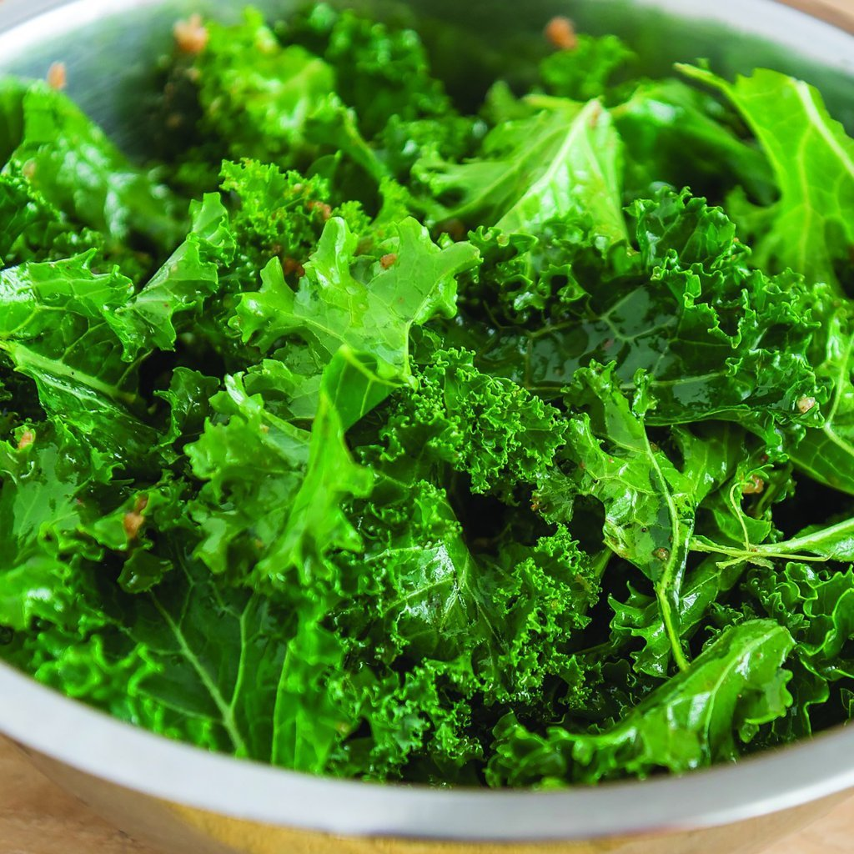
Ethiopian Blue Kale
Also known as Amara, Gomenzer, Abyssinian mustard, Texsel greens and Habesha Gomen, this kale has a smooth, full flavor, which is also sweet and not bitter. It is a versatile green that is so tender it can be eaten fresh, mixed into salads, or cooked in oil with garlic. It is beautiful, too! Pale purple stems spread to gentle blueish-green leaves.
Culture: Fertile soil with pH between 5.5 and 6.8.
Spacing: 12" apart
Irrigation: Once established, water one inch per week.
Fertilization: Fertilize every six to eight weeks to helps the kale grow strong and robust and keep it producing healthy, sweet leaves. Kale responds well to fish emulsion or compost tea.
Maturity: 45-75 days. Pick off the outside leaves first if just harvesting individual leaves. If harvesting the entire plant, cut the stem down to about two inches above the soil with one clean cut. This will allow the plant to continue to produce leaves. Harvest regularly as leaving leaves on plant for long produces bitter, tough leaves.
https://sowtrueseed.com/products/kale-ethiopian-organic

Kale is compatible with beets, celery, cucumbers, dill, lettuce, nasturtium, onions, spinach, Swiss chard, and many herbs (especially in the mint family). It is incompatible with tomatoes and strawberries.

