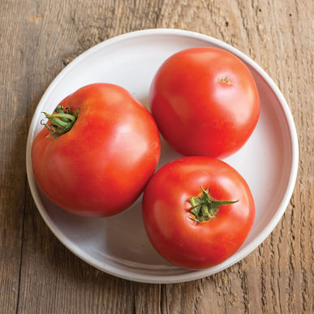
Big Beef Tomato
Nice combination of size, taste, and earliness. Large, averaging 10-12 oz., mostly blemish-free, globe-shaped red fruit. Full flavor – among the best – and ripen early for their size. Broad disease resistance - high resistance to Alternaria stem canker, Fusarium wilt races 1, 2, gray leaf spot, nematodes, tobacco mosaic virus, and Verticillium wilt. AAS winner.
Indeterminate: Train to a vertical support and prune for best results.

Space seedlings 24-36 inches apart. Transplant so that soil level is just below the lowest leaves.

Fertilize to ensure abundant soil phosphorus for early high yields. Too much nitrogen causes rampant growth and soft fruits susceptible to rot. Abundant soil calcium and an even supply of soil moisture prevents blossom end rot.

Maturity/Harvest: 70 days from transplant

Tomatoes are compatible with basil, beans, chives, cucumbers, garlic, lettuce, marigolds, nasturtium, onion, parsley, and rosemary; all of which help control pests. Tomatoes are incompatible with broccoli, cauliflower, corn, and dill. Carrots grown with tomatoes will have good flavor but stunted roots.

