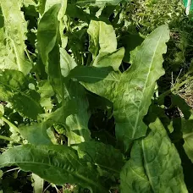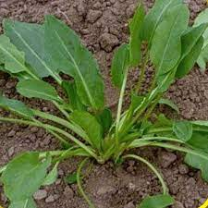
Large Leaf Sorrel

Slightly tangy, the lemon flavor adds zest to salads and is especially good with fish. Can also be cooked like spinach and used in soups. Leaves grow to 8" long. Perennial!

Culture: Keep the soil rich, well-drained soil with pH of 5.5-6.8. Keep moist for best tasting leaves. A layer of mulch may keep soil cool, control weeds, and keep sorrel from bolting. When plant bolts, cut it off at base of soil and it will produce a new crop of leaves. Watch out for slugs and use Sluggo Plus to control them.
Spacing: Sow seeds thinly 1/4" deep and press soil down to ensure good contact. Germination should take place in 21 days. Thin to 12-15 inches apart in rows 18" apart.
Irrigation: Greens need consistent water to produce delicious, tender leaves. Ideally, use a soaker hose or drip irrigation to provide even, regular moisture.
Fertilization: Side-dress with compost or granular fertilizer applied mid-season.
Maturity: 35-40 days for baby leaves, 120 days for mature plant. Fresh leaves can be harvested as soon as their length reaches 3-5". Harvest the outer leaves until the plant becomes well established. When fully matured (12-18" tall), cut the entire plant at soil level after which it will regrow. Small, tender leaves have the mildest flavor, while large leaves make excellent greens when cooked (cooking greatly lessens the sharpness of their flavor). Sorrel also freezes well.
https://www.everwilde.com/product14636.html
Garden or common sorrel is a close relative of rhubarb. Sometimes it is referred to as dock. However, the term "dock" has been used in Britain to include all members of the family Polygonaceae. Owing to its tart flavor, it is sometimes called sour dock and sour grass. In fact, sorrel derives from surele, which is French for "sour."
https://edis.ifas.ufl.edu/publication/MV136#:~:text=Sorrel%20has%20been%20grown%20successfully,reset%20to%20increase%20the%20planting.

As well as being a culinary herb, this is also a reliable companion plant. It does particularly well when planted alongside other herbs and is a good companion for strawberries.
Garden sorrel struggles when planted alongside tall plants such as beans or corn. Taller plants can block out light, stunting the growth of the sorrel.

