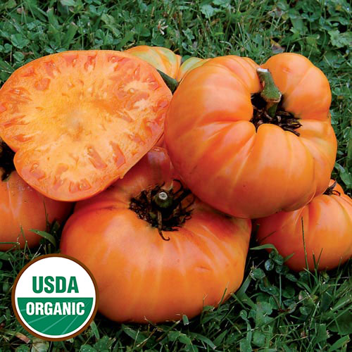
Kellogg's Breakfast Tomato

Large orange beefsteak fruits grow to 1-2 pounds. Rich flavor with good acid to sugar balance. Very productive. Thin-skinned, meaty tomatoes have few seeds and a sweet and tangy flavor. Juice and inside flesh have the same color as orange juice.

Indeterminate: Train to a vertical support and prune to encourage light and air flow.

Space required is 24-36 inches! Transplant so that soil level is just below the lowest leaves.

High heat and drought tolerant.

Fertilize every two weeks after established outdoors, using lower nitrogen and higher phosphorous and potassium blend (4-6-8) to promote blooming and fruit set without excess green production.
Maturity/Harvest: 80-90 days after transplant

Tomatoes are compatible with basil, beans, chives, cucumbers, garlic, lettuce, marigolds, nasturtium, onion, parsley, and rosemary; all of which help control pests. Tomatoes are incompatible with broccoli, cauliflower, corn, and dill. Carrots grown with tomatoes will have good flavor but stunted roots.

