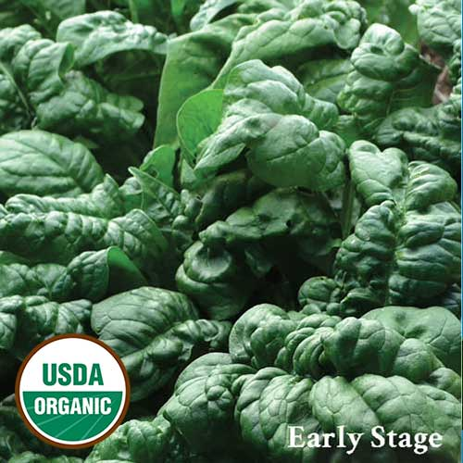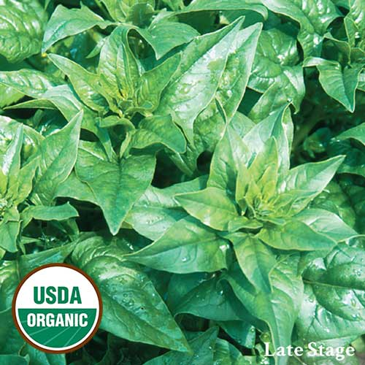
Bloomsdale Spinach
Vigorous upright plants with dark-green glossy, savoyed leaves, this variety is very tender with an excellent flavor. Plant grows to 10" with 2-3" long leaves. A quick growing variety that produces heavy yields and is slow to bolt.

Culture: Prepare planting area with organic matter, such as compost well blended with quality garden soil. The optimum temperature to germinate spinach is 70˚F. It is very difficult to achieve good germination rates in temperatures greater than 85˚F.

Spacing: Direct sow seed ½ inch deep and 1 inch apart. When sprouts are about 2 inches high, thin so that you have a spinach plant every 6-8 inches.

Irrigation: Keep the surface of the soil moist to allow the shallow roots to absorb moisture, as well as to keep the soil cool. Watering lightly and regularly week is better than periodically soaking spinach. Consistently damp but never soggy soil is key to raising healthy, delicious spinach.

Fertilizer: Recommend Fish Emulsion or liquid fertilizer, as granular fertilizers are difficult to apply without disturbing spinach’s shallow roots and burning the leaves.

Matures in 39-60 days, depending on stage at which you harvest. For best yields, harvest continually and make successive plantings every 10 days.

https://www.seedsavers.org/bloomsdale-organic-spinach

Don’t wait too long to harvest or wait for larger leaves; bitterness will set in quickly after maturity. The whole plant can be harvested at once, and cut at the base, or leaves may be picked off plants one layer at a time, giving inner layers more time to develop.

Tip: Radishes attract leaf miners away from spinach and the damage that the leaf miners do to radish leaves does not prevent the radishes from growing underground.

https://www.almanac.com/plant/spinach

Beans make excellent companions for spinach. As the beans grow, they'll provide shade to protect the tender spinach plants from the heat. Spinach is a good companion for Brassicas, eggplants, leeks, lettuce, peas, radish, and strawberries, particularly. Don’t plant spinach near potatoes.
https://www.westcoastseeds.com/blogs/garden-wisdom/companion-planting

