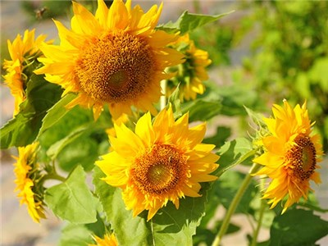
Teddy Bear Sunflower
Beautiful 3”- 6” double, deep yellow blooms. Plants grow 18”- 24” tall, and the double blooms are very unique! This is a superb variety. https://www.rareseeds.com/teddy-bear-sunflower/
Plant seed one-inch deep and water to keep moist but not drenched. Germination takes 7-14 days. Transplant carefully when seedling has first true leaves. Sunflowers typically do not need fertilization, but you can work in a little time-release fertilizer if you have poor soil quality.

Teddy Bear Sunflower
Beautiful 3”- 6” double, deep yellow blooms. Plants grow 18”- 24” tall, and the double blooms are very unique! This is a superb variety. https://www.rareseeds.com/teddy-bear-sunflower/
Plant seed one-inch deep and water to keep moist but not drenched. Germination takes 7-14 days. Transplant carefully when seedling has first true leaves. Sunflowers typically do not need fertilization, but you can work in a little time-release fertilizer if you have poor soil quality.

