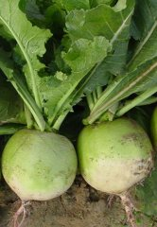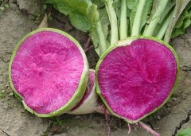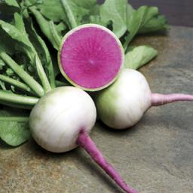

Mantanghong Beauty Heart Watermelon Radish

Globe-shape, green shoulder with dark pink flesh, 3-inches round, weighing up to a pound each! Because of their color, they are the perfect radishes to carve into flower shapes as garnish.

Flesh is crispy with a sweet flavor perfect for salads cooking. Enjoy roasted or sautéed with parsnips, carrots, or other root vegetables, or try them raw. Thinly slice, top with fresh squeezed lime and a little salt and pepper or sweetener.

Culture: Ideal soil pH: 5.5–6.8. Ideal soil temperature: 55-75°F.

Spacing: Cover seeds with ½" of fine soil; firm lightly and keep evenly moist. When sprouts emerge (4-6 days), thin to 3" apart. If planting more than one row, maintain distance of 6-12" between rows.
Irrigation: Water continuously and evenly. Keep the soil moist but not saturated. To promote uninterrupted growth, neither over water or allow the soil to dry out. When watering, it is best to use low pressure at the soil level. If you water with overhead sprinklers, water early in the day so the foliage has time to dry off before evening, to minimize disease problems. Unlike many vegetables, radishes do not benefit from an occasional deep soak. They do much better with several shallow watering’s per week.

Fertilizer: Radishes do not require fertilization to produce well. Adding nutrients to the soil before you plant usually supplies enough nutrients to feed these quickly developing vegetables.

Maturity: Harvest in 60-70 days. Note: They will be hot when eaten small and get sweeter if allowed to grow larger.

https://www.kitazawaseed.com/seed_261-111.html

A video describing the seeding, thinning, watering, and harvesting of watermelon radish.
https://www.reneesgarden.com/blogs/gardening-resources/how-to-grow-watermelon-radish

