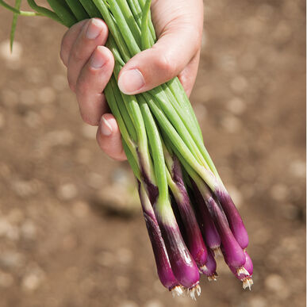
Deep Purple Bunching Onions, Organic

Rich reddish purple scallions. The first red buncher that is highly colored at any temperature.

Culture: Bunching onions prefer a light, fertile, well-drained soil with lots of organic matter and pH 6.2–6.8. Soil that is too acid or alkaline will cause slow growth and late maturity.

Space: Plant ¼-½ inch deep and 1/4 inch apart in rows 2-3 inches wide, or broadcast seeds. Once seedlings are well established, thin to an inch apart. Keep well cultivated so that plants receive maximum light.

During the growing period hill the plants with soil 2 or 3 times, higher each time. This forces the leaves higher up the plant resulting in extra-long blanched stalks and a much greater edible portion. Cultivation should be shallow since onion roots are near the soil surface.
Once established, plants can be divided easily to spread throughout your garden, or to share with friends and neighbors! To divide plants, just dig up a clump, carefully split the root ends into several sections, and replant.

Irrigation: Consistent soil moisture

Fertilize: Nitrogen should be abundant during the period of active leaf growth.

Apply first application (high nitrogen, such as blood meal) three weeks after planting. Will benefit from liquid fish emulsion or comfrey tea every 3 weeks thereafter.

Note: Onions and weeds do not mix. Experiments have shown yield reductions of 4% per day in the presence of weeds, or 50% reduction of yield in 2 weeks. A layer of organic mulch will help suppress weeds and will aid in maintaining moisture and nutrient levels.

Maturity: 60 days

https://www.johnnyseeds.com/vegetables/onions/bunching-onions/deep-purple-organic-onion-seed-491G.html

Onions are compatible with tomatoes, sweet peppers, spinach, lettuce beets, parsnips. Onions also repel insect pests of strawberries.

Incompatible with peas and beans.

