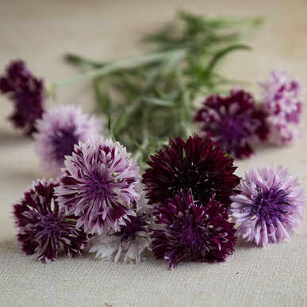
Centaurea, Classic Magic “Bachelor’s Button”
Abundant 1–1 1/2" flowers on upright plants. Double and semidouble bicolor blooms in black & plum, black & white, and purple. Attractive, frosty appearance. Elegant addition to salads and desserts.

- Cut flower, edible flower, and beneficial insect attractant. Can be used as dried flower, though blooms are quite small once dried. Effective when massed for color in beds and borders.
- Can tolerate low temperatures of 41 degrees Fahrenheit.
- Centaureas are very easy to grow from seed started indoors or out.
- Harvest fresh when flowers are ¼-½ open.

Trivia: The term bachelor’s-button refers to the long-lasting quality of the flower when it is cut and placed in the buttonhole of a suit or shirt; decades ago, bachelors sported the flower when they went courting.

