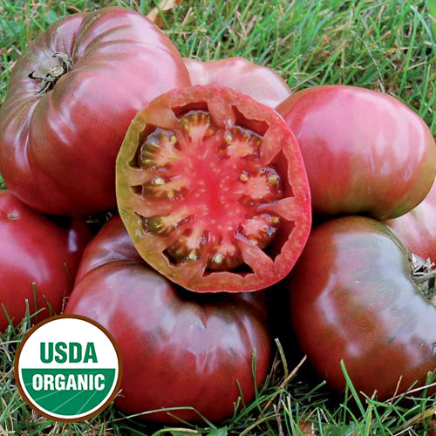

Tomato, Cherokee Purple
Solanum lycopersicum

- Dusty rose-brown fruits grow to 12 ounces
- Sweet flavor
- Indeterminate - Fruit ripens throughout the season
- 75-90 days from transplant

Introduced by Craig LeHoullier of Raleigh, NC, in 1991 from seed obtained from J. D. Green of Tennessee. Uniquely colored dusty rose-brown fruits weigh up to 12 ounces. Delicious sweet flesh. Indeterminate, 75-90 days from transplant.

Plant in full sun, 24 to 36 inches between plantings, and provide cage, stake, and/or trellis.

