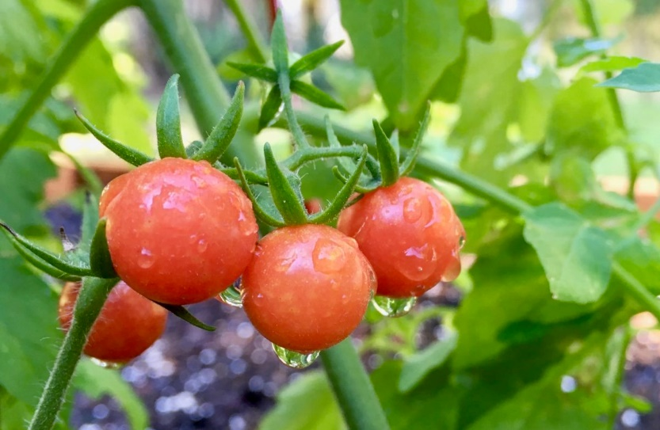

Everglade Tomato

Diminutive, about the size of a dime and usually smaller, with tremendous, sweet taste. Great eaten right off the vine or in salads and as garnish. currant tomato. Closely related to a wild tomato originating in South America, at some point normalized to grow wild in Florida. Fairly pest resistant indeterminate tomato plant, it can practically be grown year-round from Central to South Florida. Baring the most extreme environmental conditions, the Everglades Tomato will continue to self-seed and if left alone, can take over a garden area.

Culture: Plant in fertile soil, amended with compost. Provide even moisture. Transplant so that soil level is just below the lowest leaves.

Spacing: Space seedlings 24-36 inches apart. Train to vertical support.

Irrigation: Require 1-2 inches of water each week, depending on weather conditions. Water early in the day and avoid getting water on stem and foliage to prevent disease. Keep soil evenly moist.

Fertilization: Use a generally well-balanced NPK vegetable fertilizer with a bit lower nitrogen (excessive nitrogen can promote excessive foliage and poor fruit set.)

Maturity/Harvest: 50 days

Harvesting Tip: Instead of picking fruit by fruit, cut the entire cluster off the vine when all the fruit is most of the way ripe. Alternatively, break the fruit off the vine one by one with their little green hat on (the technical term is "peduncle") since the fruits skin tends to rip when it is removed hastily.

https://whitwamorganics.com/products/everglade-florida-heirloom-tomato-seedling-1?

Tomatoes are incompatible with broccoli, cauliflower, corn, and dill. Carrots grown with tomatoes will have good flavor but stunted roots. Compatible with basil, beans, chives, cucumbers, garlic, lettuce, marigolds, nasturtium, onion, parsley, and rosemary; all of which help control pests.

