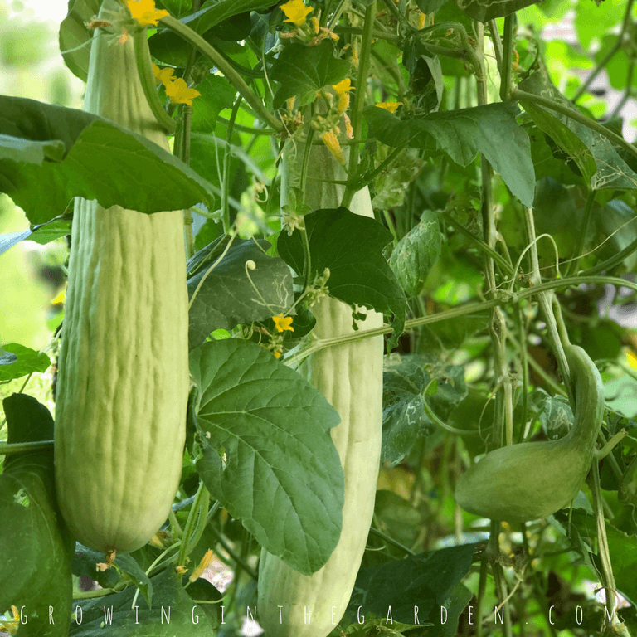
Armenian Cucumber
Sometimes referred to as snake melon, serpent and yard long cucumber. This variety is light green, heavily ribbed, and spineless. Fruits are crisp, mild and sweet flavored. It is a burpless cucumber and its thin skin does not require peeling. Very heat tolerant.
Culture: Ideal soil temperature is 78-86˚F. Ideal soil pH between 6 and 7. Optimum growing temperatures are 75°F daytime and 60 F at night.
Spacing: Sow seeds 1" deep, 2-4" apart. Thin to 10-12"
Trimming and Staking: Train to climb a vertical support for better air circulation, straighter fruits and ease of harvest.
Keep the primary vine and support with trellis. Each node on the vine has a tendril (important for attaching to trellis and/or stake), a fruit, a leaf (important for photosynthesis), and a growth point. Prune growth points for improved plant health and production.

Helpful video on pruning growth points: https://www.youtube.com/watch?v=TGkFJh5bKGg
Irrigation: Keep soil moist.
Fertilization: Liquid fertilizers low in nitrogen and higher in phosphorus and potassium fertilizer are ideal. (Excessive nitrogen produces excess foliage at the expense of blossoms and fruiting.) Once established and blooming, discontinue fertilizing.
Maturity: Harvest in 65-70 days.
Use in salads and for pickling. Marinate in su (rice) vinegar (universal Japanese sweet/sour dressing) for a refreshing salad.
https://www.kitazawaseed.com/seed_015-22.html

Plant beside beans, Brassicas, celery, corn, dill, kohlrabi, lettuce, onion, peas, radish, and tomatoes. Avoid planting near potatoes and sage. Both corn and sunflowers can act as a trellis for cucumbers to good effect. Dill will help cucumbers by attracting predatory insects, and nasturtiums will improve the flavor and growth of cucumbers.
https://www.westcoastseeds.com/blogs/garden-wisdom/companion-planting

