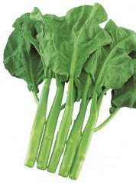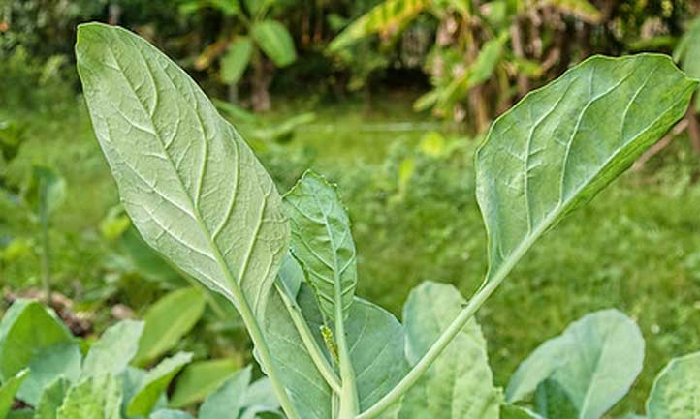
Suiho, Hybrid – Chinese kale/broccoli
Fresh, green, soft and delicious with wide ¾” stem, this variety of Chinese kale/broccoli has round medium green leaves that are slightly wrinkled. Also known as Noble Jade or Emerald Green variety. The plant grows about 14" tall and is semi-spreading. Resistant to diseases and heat tolerant.

Culture: Prepare fertile, well-drained soil. Can be planted yearly around in sub-tropical area. Ideal germination temperature is 65-75°F. Grows well in cooler weather.

Spacing: Sow seeds 1/8 - ¼" deep, ½” apart and thin, leaving 8 inches between each sprout.

Note: Harvest main stalk when about 8-10" tall and when 2-3 flowers are about to open. After this cut, the plant branches freely for an extended harvest but stems and leaves will be smaller. Spreading habit.

Irrigation: Keep soil moist.

Fertilization: Mix ¼-½ cup complete organic fertilizer into the row before planting.

Maturity: 45-55 days. Harvest stalks with the leaves and flower buds intact by cutting each stalk near its base. Always harvest before the flowers open. Use in stir-fries or like broccoli.

https://www.kitazawaseed.com/seed_296-150.html

Suiho is in the brassica family. Avoid planting near peppers and tomatoes.

