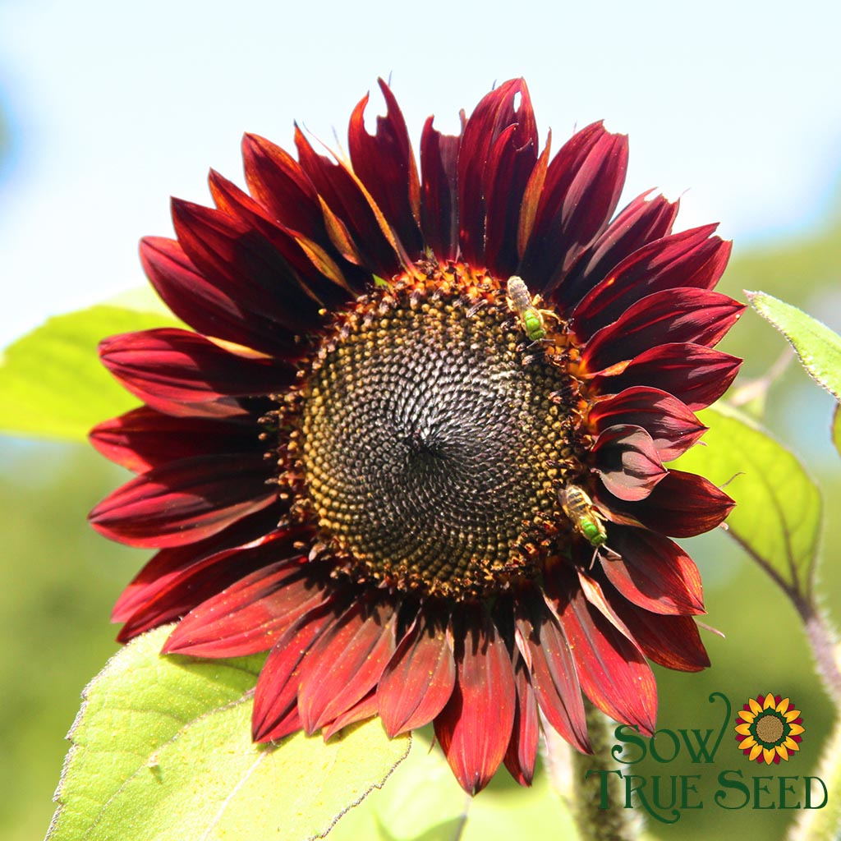

Sunflower, Evening Sun, Organic - 45 seeds - 50% with deep burgundy color, 50% mixed reds and some orange. Visually they just can’t be beat for their long lasting, 4–6” blooms like the reds of the setting sun. Ideal soil temperature 65-85 degrees F. Full sun. Plant seed 1” deep and space 4-6” apart. Mature spacing 12” apart. Days to sprout 5-12. Pinch back when plants reach 8” tall to encourage branching. Will grow as tall as 6-8’ with somewhat oblong leaves. Harvest in 80-120 days. Seed viability 4-6 years.

Dark centered large 8-10" flowers in rich coppery shades have a long bloom time, opening more flowers from the many-branched stems. Excellent cut. Feed the birds later in fall as they ripen seed.
Lifecycle: Annual Hardiness: Half Hardy Annual Size: 6-8' h x 2.5' w Season: Summer to fall
Seed to Bloom: 12-14 weeks Sun: Full sun Soil: Regular to rich, well-drained
SOWING INSTRUCTIONS:
Depth: Depth: 1/4"
Starting Indoors: Not recommended; sunflowers grow very quickly and do best when sown directly.
Starting Outdoors: Direct sow after last frost. Thin to 1' apart.
PLACEMENT & CULTIVATION
Perfect as a border or along a fence but will brighten up almost any location with full sun and rich, well-drained soil, though it will tolerate wetter, average soils. Space seeds 4-6 inches apart. Pinch back when plants reach about 8 inches tall to encourage branching.
Grows With: Achillea (Yarrow), Aster, Gaillardia (Blanket Flower), or other sunflowers.
Water Use: Medium
Watering Details: About 1” of water per week, though they will tolerate some dryness, at the expense of sturdiness in windy conditions.
Soil pH: Acidic to neutral
Fertilizer: Fertilize with an organic, water-soluble fertilizer once per month.
Diseases & Pests: Prevent botrytis susceptibility during wet spells by spacing properly and planting in a location with good air circulation. If desired, cover spent flower seed heads to prevent birds from feasting upon the seeds.
WHAT YOU’LL GROW
Plant: Green, branching stems as tall as 6-8' with large, somewhat oblong leaves.
Flowering: Copper and mahogany petals with chocolate brown centers
Seeds: Each flower head will turn into a seed head of achenes—black, oblong seeds. If planning to collect, cover with netting or cheesecloth to prevent birds from helping themselves.
When to Cut: Fully opened flowers
FUN FACT
The flowers will turn to face the sun, particularly during bud phase. This process is referred to as heliotropism.

