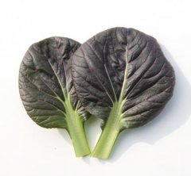
Red Tatsoi, Pak Choi Hybrid
Vigorous hybrid with medium sized, spoon-shaped red-violet leaves and a mild, sweet mustard flavor. Harvest from baby leaves for salads to full maturity.

Culture: Prepare fertile, well-drained soil. Optimum growing temperatures are in the 60s°F. Most vegetables leave having purple color is called “anthocyan” which is generally developed by lower temperature.

Spacing: Sow seeds ¼- ½" deep, 1-2" apart. After germination, thin sprouts to 6-8" apart. Add thinned sprouts to salads or stir-fry dishes.

Irrigation: Keep soil moist.

Fertilization: Provide foliar feeding of compost tea when young.

Maturity: 20-30 days baby leaf; 45 days full maturity. Use in salads and stir-fries. Sauté or braise.

https://www.kitazawaseed.com/seed_446-77.html

Compatible with beets, beans, carrots, chamomile, chard, cucumbers, dill, kale lettuce, and spinach.

Consider interspersing bok choy with other vegetables. A bit of bok choy scattered here and there is less likely to attract insects or cabbage worms than a large plot of this leafy vegetable. Companion planting offers a potential solution to pest control while providing other benefits. Bok choy is vulnerable to cabbageworms, maggots, flea beetles and aphids. Select herbs, such as thyme and cilantro, as well as vegetables, such as celery and onions, and nasturtiums to repel them.

