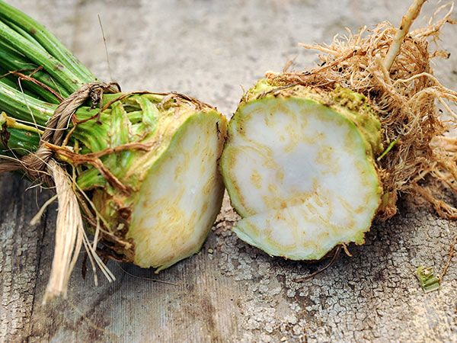
Celeriac, Giant Prague
Grown for its large, white roots that are superb raw, fried or in soup.
Culture: Fertile soil with a pH range of 6.0–7.0. A generous amount of compost worked deeply into the soil before planting helps retain moisture and add nutrients. Grows best in cool weather, especially when nights are cool.
Spacing: Sow 6 seeds per inch, 1/8" deep. Seedlings typically emerge in 2–3 weeks. When they are 3-4 inches tall, thin to 6–8" apart.
As the plants grow, soil can be mounded around the exposed root to keep it moist and cool.
Irrigation: Requires consistent supply of moisture throughout the season for optimum flavor and yield. Consider mulching with food-grade straw to conserve soil moisture. Do not let the soil dry out!
Fertilization: Apply every 3-4 weeks with a high potassium fertilizer (4-4-8, for example).
Remove lower and lateral leaf shoots while celeriac is growing to produce a nice crown. Leaves can be used to flavor soups and stews.
Maturity: 110 days. Harvest when 3–5" diameter. After harvest remove field heat by dunking plants in cold water.
https://www.rareseeds.com/catalog/product/view/id/1006/s/celeriac-giant-prague/

Compatible with bush beans, lettuce, spinach, English peas. Do not plant celeriac with pumpkins, cucumbers, or squash.

