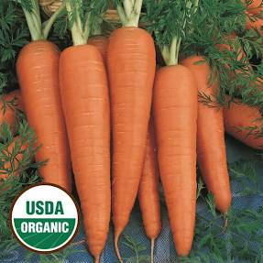
Organic Danvers
Seven-inch long carrots produce well, even in heavy soil. They are crisp, sweet, delicious, and ready in as little as 65 days. Quite heat tolerant. Plant a few every 2 weeks for a continuous harvest.

Culture: Loosen soil and work in organic matter. Best grown early spring or late fall when daytime temperatures are 60-70°F.

Spacing: Sow seeds ¼ inch deep, barely covering with soil. They need light to germinate (typically in 14-21 days). When carrot tops reach 2-inches in height, gently thin them to be 4" inches apart. Use a small scissor to cut rather than pull, so that you do not disturb neighboring carrot roots.

Irrigation: Carrots like good drainage and regular watering, although the soil should be moist and not saturated. It is important not to allow soil to dry out.

Note: When the tops of the carrots begin to emerge form the soil, cover them with soil or organic mulch to keep them tender. Keep weeds under control to avoid carrots from becoming stunted.

Fertilization: When carrot tops are 3" high, apply fertilizer that is low in nitrogen and higher in potassium. Avoid using nitrogen-rich vegetable fertilizers which are known to cause carrot growth abnormalities.

Maturity: 73 days. Begin gathering baby carrots when they are large enough to eat, allowing the remaining carrots to reach larger size. If they become difficult to pull, make sure the soil is moist.

https://www.everwilde.com/store/Organic-Danvers-Carrot-Seeds.html

Carrots are compatible with beans, Brassicas, lettuce, onions, peas, peppers, pole beans, radish, and *tomatoes.

Avoid planting with dill, parsnips, and potatoes.

Generally speaking, it is a good idea to keep some space between root crops so they don’t compete for available phosphorus.

Planting carrots with aromatic herbs or onions may repel the carrot fly and its maggot. Chives also benefit carrots. Other compatible herbs include rosemary and sage.

*Carrots planted near tomatoes may have stunted roots, but will have exceptional flavor.

