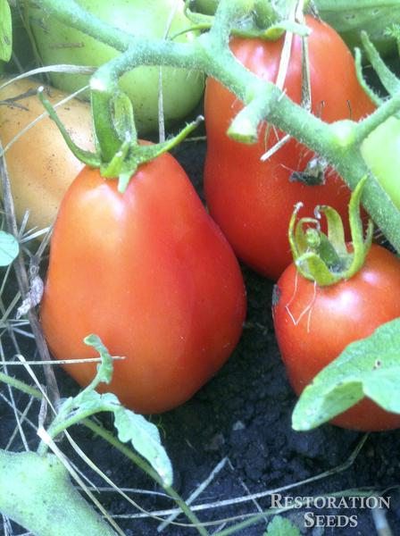
Roma VF Tomato - Organic
Plum to round shape, thick walled, red 4-6 oz medium-sized fruit popular (paste type) for canning, sauce, juice or drying. Heavy producer.

Space seedlings 24 inches apart. Transplant so that soil level is just below the lowest leaves.

Determinate – does not need pruning or trellising.

Apply phosphate for high early yields and to avoid blossom-end rot. Too much nitrogen causes excessive vegetation. If fruit cracks, reduce watering.

Maturity/Harvest: 65-75 days

Tomatoes are incompatible with broccoli, cauliflower, corn, and dill. Carrots grown with tomatoes will have good flavor but stunted roots. Compatible with basil, beans, chives, cucumbers, garlic, lettuce, marigolds, nasturtium, onion, parsley, and rosemary; all of which help control pests.

